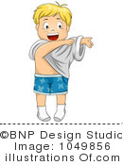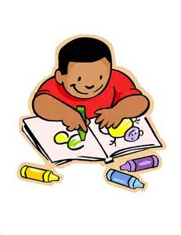

**Reception Class**

**Medium term planning-Spring 2**

**Topic(s)**

* Under the Sea-Commotion in the Ocean, The Snail and the Whale.

(BLUE PLANET AQUARIUM)

* Space- Whatever Next, Aliens Love Underpants.

**Key Skills**

**Self-care**

* Children will attempt to get themselves changed for PE as independently as possible.
* Children to put on and fasten their own coat throughout the day.
* Listen to the adult and follow the instruction.
* Share and take turns.
* Handle equipment with increasing safety.

crest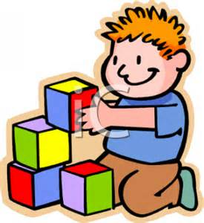

**Expressive Arts and Design**

* Introduces a story or Use simple tools and techniques competently and with care eg Play-doh and craft.
* Handle objects with increasing care-construction equipment.
* Explores the different sounds of instruments.

**St. Charles’ Catholic Primary School**

*“Love, Learn, Grow Together.”*

**Key Skills**

**Mathematics**

* Begins to use language relating to +/-
* In practical activities and discussion, beginning to use the vocabulary involved in adding and subtracting
* Finds the total number of items in two groups by counting all of them.

**Key Skills**

**Literacy**

* Recognise and Write Set 1 and Set 2 Sounds
* Segment the sounds in simple words and blend them together, knowing which letters represent some of them.
* Begin to break the flow of speech into words.
* Joins in with stories and is able to talk about the main events.
* Enjoys an increasing range of books.
* Attempts to write their own name and other things such as labels, lists and captions.
* Attempt to write sentences with some support.

**Key Skills**

**Communication and**

**Language**

* Maintain attention, concentration and sits quietly during an appropriate activity.
* Ask and answer questions, showing awareness of the listener.
* Listen to stories with increasing attention and recall.
* Role-play a range of characters and situations.
* Uses language to imagine and recreate roles and experiences in play situations.

**Key Skills**

**Understanding the World**

* To show an interest in different occupations.
* Looks closely at similarities, differences patterns and change.
* Interacts with age appropriate software.

**Key Skills**

**Physical Development**

* Show increasing control over an object in pushing, patting, throwing, catching or kicking it.
* Negotiates space successfully when playing games with others.
* Beginning to move in a variety of ways
* Beginning to use one-handed tools and equipment.
* Is able to travel in a variety of ways.