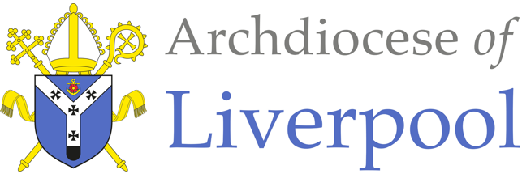
*Note to parents.
This work comes from the Come and See Religious Education programme which is taught in all Catholic schools in the Archdiocese of Liverpool. We have given a general guide to the learning opportunities that your child may have come across in school and have only suggested and selected a small amount of the programme. The activities aim to keep Religious Education practical and fun. They are in Year groups however, there is no harm in completing other year group work as this will help your child to remember and strengthen their learning. Please only choose the activities you and your child wish to complete. There are lots of suggestions to help you choose.
The first part of learning is called – EXPLORE. This shares your child’s everyday experiences and helps them to see how the Catholic faith is lived in their everyday lives. The second part, called – REVEAL shares bible stories that links to their everyday life.

RELIGIOUS EDUCATION – YEAR 3 – PENTECOST

EXPLORE: The energy of fire and wind

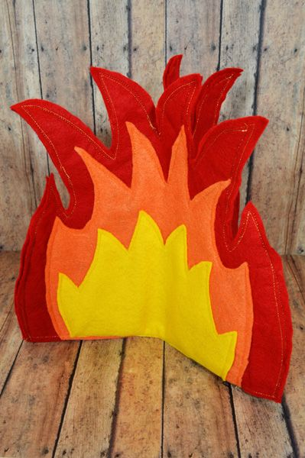
Choose Activities
- Talk together about fire and wind.
- Fire - Explore the danger of fire and the safety measures we must take. Think of all the things that you can use fire for: starting a car, cooking, light, warmth, making things, metal work, glass, firing pottery, for purifying etc. Talk about the qualities of fire – it warms, melts, cooks, burns, change liquids and solid substances. Fire gives us light.
- Wind – if you have balloons use them to show wind power. Blow up the balloon and put the balloons down on the floor. What happens? How could you make them stay on the spot? Can you always control the balloon? Why not? Will it go where you want it to? What makes it move?
- Now for the fun part! Letting the air out of the balloon. Slowly at first and then quickly. Did you see anything happen? Did you hear anything? What made the noise? What made the movement?
- Think about wind and how we can use it in everyday life: drying things, windmills, wind farms and its use in nature: blowing away old leaves, distributing seeds etc.
- Show some BBC learning zone clips on wind power and fire e.g. making pottery. Notice how both wind and fire engage the senses: seeing, touching, hearing and smelling. Talk about how they do this.
- Make streamers, a kite, large pinwheel to blow in the wind.
- Make a flame collage, picture, building a model of a fire.

Read together and share:
- You Tube Non-Fiction -
Read aloud of Wind by Eric Edison- Story time with Ms. Caruso

REVEAL: The wonder and power of the Holy Spirit.

Jesus gave us the Holy Spirit when he went back to his Father in heaven. The Holy Spirit showered gifts upon the friends of Jesus, gifts which were different kinds of energy, gifts which gave them strength. They needed strength to go out and tell everyone about Jesus and share the Good News he gave us. The Holy Spirit has given special gifts to us all.

The gifts of the Holy Spirit help us in everyday life. There are seven gifts, which help people to lead good lives and make use of the gifts they have. These gifts should be used to help others.
Wisdom – be sensible and thoughtful.
Understanding – be loving to one another and take time to see what is happening.
Counsel – using wisdom and understanding to come to a good choice about something.
Fortitude – be brave and stand up for what you believe to be right and holy.
Knowledge – making right choices and good understanding. It takes practice to have true knowledge.
Piety – be respectful to God, for one another and for yourself.
Fear of the Lord - the awe and wonder of God. Be amazed by the love and goodness of God.
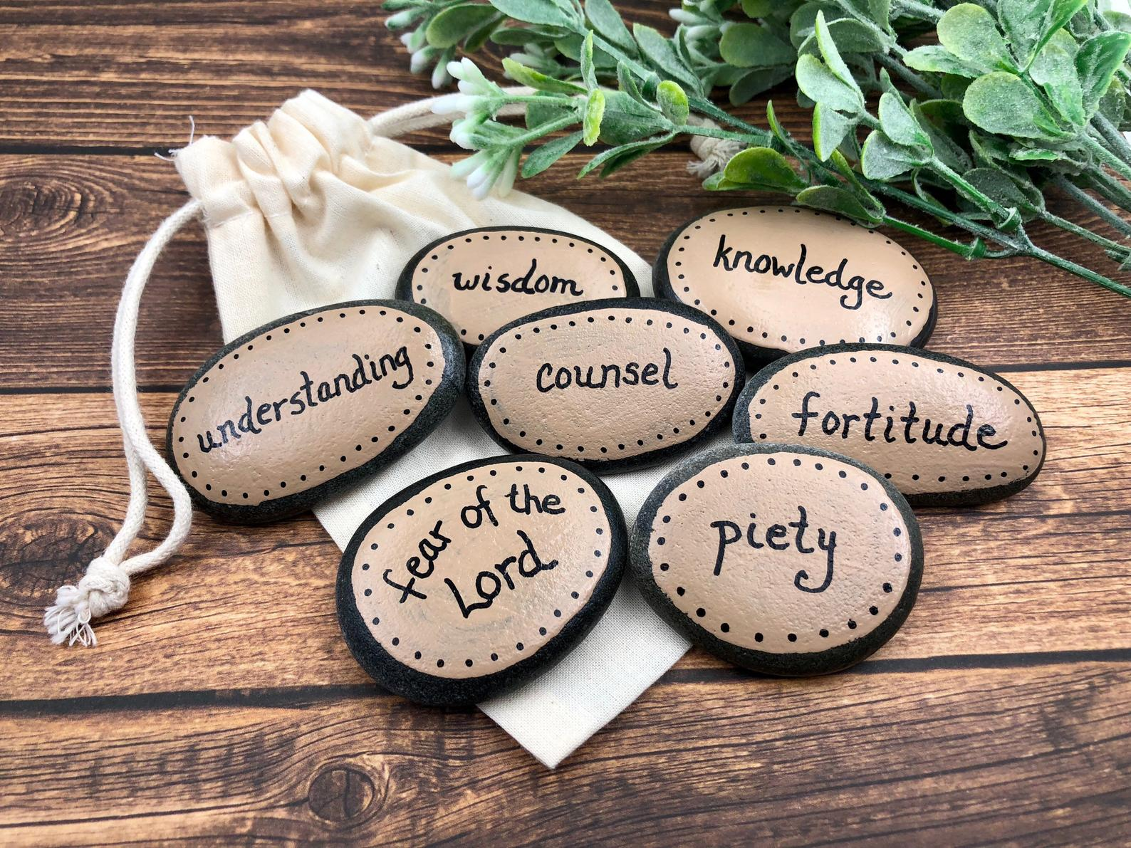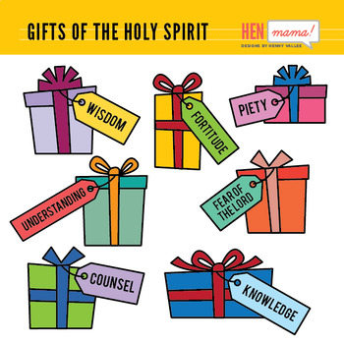
Some of the words are difficult to understand. Just think about one at a time. They all link together.

Choose Activities
- Talk together about which of the gifts of the Holy Spirit do you think is the most important to you? Why?
- How do the gifts of the Holy Spirit help us to help others?
- Where have you seen people using the gifts of the Holy Spirit? - at home, school and in the local community? There will be so many examples of these gifts as we are seeing lots of people helping those who are poorly, lonely, need shopping etc.
- Make a poster, collage, drawing or painting of the amazing ways the gifts of the Holy Spirit are being used around in our country and around the world.
- Decorate pebbles from your garden or cut out paper gift boxes to write the gifts of the Holy Spirit.
- Write a letter or email to say thank you to someone who is using their gifts of the Holy Spirit to help others.

