*Note to parents.
This work comes from the Come and See Religious Education programme which is taught in all Catholic schools in the Archdiocese of Liverpool. We have given a general guide to the learning opportunities that your child may have come across in school and have only suggested and selected a small amount of the programme. The activities aim to keep Religious Education practical and fun. They are in Year groups however, there is no harm in completing other year group work as this will help your child to remember and strengthen their learning. Please only choose the activities you and your child wish to complete. There are lots of suggestions to help you choose.
The first part of learning is called – EXPLORE. This shares your child’s everyday experiences and helps them to see how the Catholic faith is lived in their everyday lives. The second part, called – REVEAL shares bible stories that links to their everyday life.

RELIGIOUS EDUCATION – YEAR 4 – PENTECOST

Read together and share Cameron’s birthday present

EXPLORE: Good news brings life

Mum said that he was a bit late, but Cameron just muttered something, and went to his room. His Mum shouted up that if he got on and did his homework now, he would have time to play with his monster after tea. That made Cameron feel even worse. His Dad thought Cameron looked sick and thought he had better go to bed rather than play with his monster car. Cameron agreed. Next morning, he was still feeling rotten. He knew his parents had saved for his present and his Dad was as excited as Cameron with it. He knew he had been silly– not to mention disobedient. All day in school, he was quiet. His friends were sympathetic, but he felt lifeless.
Another day went on like that. He heard his Mum and Dad talking about him, wondering what was wrong with him. He looked unwell and he didn’t even want to play with his monster car. They wondered if they should take him to the doctor. His elder sister, Danielle, came into to his bedroom and asked him what was wrong. She asked him where his monster car was. At first, he said nothing was wrong, but his sister had a kind way of talking to him, and eventually he told her his sad story and how awful he had felt about it, especially because his parents had been so generous and he had let them down.

Cameron’s birthday present
Cameron had just had a birthday. His parents had given him what he really wanted, a remote-control stunt monster car. He was really thrilled and had spent the weekend learning how to use it and doing lots of stunt manoeuvres. He took it to bed with him and looked at it sitting on his windowsill, sparkling in the light from the street.
Monday morning arrived and his Mum reminded him that he had to leave his stunt monster car at home and not take it to school. Cameron nodded, hoping his Mum would not notice the large shape in his school bag. When he got to school, he told all his friends about his present. He knew he could not show them in school, so suggested that they walk home through the park so he could demonstrate his monster car manoeuvres. The other boys watched as Cameron made his stunt monster do incredible things and go really fast. Someone was watching this, an older boy called Gary. Slowly he got nearer, and no one noticed him until he ran over snatched the monster and ran off with it. Cameron felt sick. What could he do? It was no good running after Gary. He would never catch him. He and his friends all went off to their homes.

Next evening, after another miserable day, when he got home, he went straight up to his room and there to his surprise was his monster car sitting on his bed. He picked it up and hugged it. Tears of joy ran down his cheeks. He quickly brushed them away. He felt like a new person. He called his sister to tell her and ask her what had happened. Danielle smiled, and told him she knew Gary’s Mum and had been round to his house. Gary’s Mum gave her the monster car and told her she wondered where Gary had got it from and that it was useless to him as he didn’t have the radio to make it work. Gary was going to be in trouble when he got home.
Cameron was jumping up and down. He was so excited that his Mum came up to see what was wrong. She said she was glad to see him looking happy and alive again. He told her the story and said he was very sorry. She said she thought he was fortunate to have such a good sister and he had learnt an important lesson.

Choose Activities

- Talk about your thoughts about Cameron. Can you answer the following questions?
Why was Cameron upset about how his parents would feel?
How was Cameron rescued and how did it make him feel?
What lesson do you think he learnt?
What do you think happened in school next day?
How does good news change the way you feel and how you act?
- Collect some good news from your family, newspapers, from the television and write a front page of your own Good News newspaper. Write how and why it was good news and how it made them feel.
- Write your own story about either yourself or someone being sad and miserable and some good news that brought them happiness and made them feel alive.

REVEAL: The new life of the Easter message is spread through the power of the Holy Spirit

Share and read together the bible reading from Acts 4: 1-26, We cannot keep silent. The apostles are witnesses to Jesus being raised to new life by God. The Holy Spirit confirmed their faith in Jesus and gave them the courage they needed to speak out about the Good News of Jesus even when they were threatened.

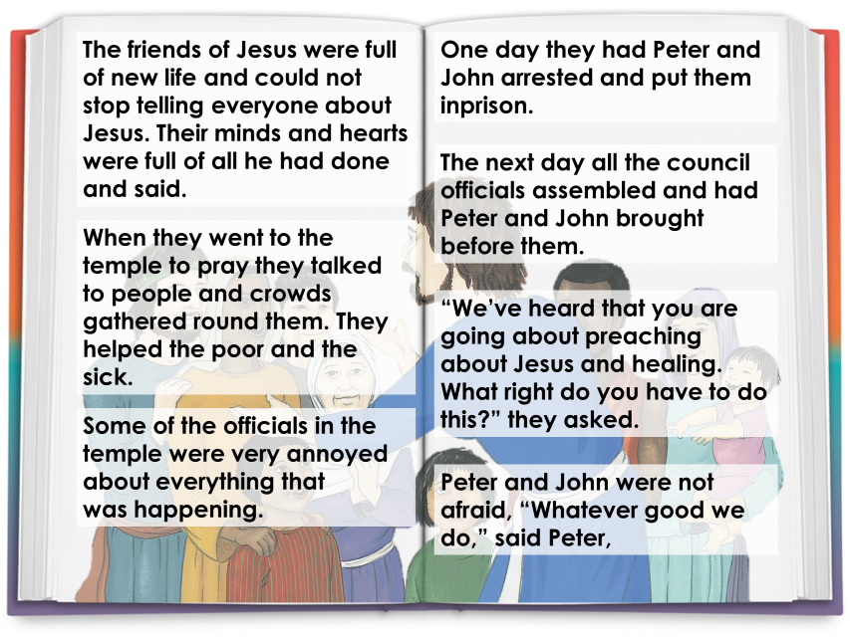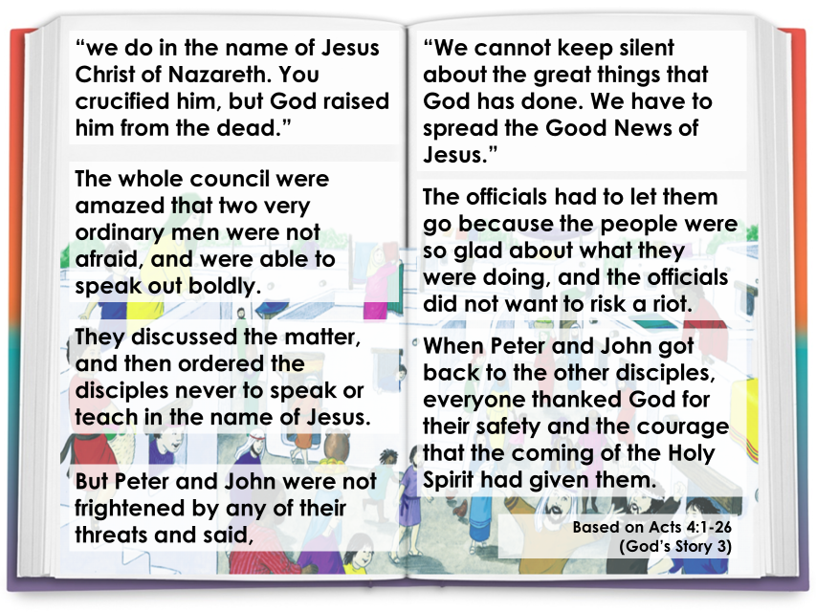
- Imagine you were a friend of Jesus who went out to tell everyone about his life and how he loved everyone. Write a speech you would give to people who have never met him or heard of him. What would you tell them about Jesus? Can you remember some of the things he did in his life to help and be kind to others? How did he show love to everyone? Think of the bible stories you have heard at school.

Choose Activities
- Can you answer these questions?
Why were the friends of Jesus full of new life?
Why do you think the officials were annoyed?
What happened to Peter and John?
How do you think Peter and John felt when they were arrested?
What did they say to the council?
How did Peter and John show their courage to the officials?
What would you have done? Why?

