A Whole School Approach to Supporting Loss, Separation

& Bereavement

Information and Resources

Updated 2017

Much of the information in this booklet has been sourced from specialist and well respected bereavement charities and organisations.

Source material is referenced throughout the document by use of logos.

Winston’s Wish

www.winstonswish.org.uk
SeeSaw

www.seesaw.org.uk
Child Bereavement UK

www.childbereavementuk.org
The National Children’s Bureau (NCB) www.ncb.org.uk

Thanks go to these organisations for their support and agreement in sharing this information.

Contents | Page(s)
Introduction | 5
Managing Bereavement in the school community: Immediate Support Strategy | 7
Informing Staff and Governors of a Death within the School Community | 8
Informing Children and Young People | 9
Children’s Reaction to Bereavement | 11
Helping Children through Grief | 13
Simple Tips for Speaking with Young People about Death | 15
How Children may feel and act… | 16
Understanding Grieving Teenagers | 19
Talking about Death with Children who have Learning Difficulties | 22
A Bereaved Pupil’s Return to School | 24
How School can help a Bereaved Pupil | 25
What do children and young people say about their experiences of loss & bereavement | 27
Building Resilience in Bereaved Children | 28
Different Cultures and Beliefs | 29
Explaining Funerals, Burials and Cremation to Children | 33
Dealing with Divorce & Separation | 36
Cyber Grieving | 38
Supporting the Emotional Health and Wellbeing of Staff | 39
Resources
Letter templates | 41
Reading resources | 43
Lesson plans and ideas | 44
Framework for developing a school bereavement policy & Sample Policy | 50
The Charter for Bereaved Children | 55
Useful websites and Contacts | 56
Acknowledgements | 61
Reading List | 62

Introduction

“Death neither obeys the school timetable nor appears on it…it enters the classroom without knocking.”

Up to 70% schools have a bereaved pupil on roll at any one time. Many staff members feel anxious about supporting a bereaved pupil in a school or an early years setting, or addressing bereavement and loss in the curriculum.

This booklet has been designed to

provide you with

✓

Practical tips and advice when facing bereavement in the school community.

✓

Letter templates for informing parents and the wider community.

✓

Template for
a whole school bereavement policy.

✓

Activities for teaching.

✓

Reading resources.

✓

Useful

websites and telephone numbers.

A parent of children under  18 dies every  _{the UK; around} 22 minutes in  23,600 a year. | 1 in 29 school children has  been bereaved of a parent or  sibling – that’s a child in every class. | Each year, around 6000 families are  bereaved by suicide. | Over 10,000 babies, children and young  people (up to  the age of 25) died in 2015.  That is 28 every day. | The incidence of childhood  bereavement in  youth offenders  can be up to ten times higher  (41%) than the national average (4%).

Often, our first thought is
“HELP!”

and we don’t know
what to say,

fearing we will
‘make it worse
.
’

The very worst thing that
could ever happen in that
child’s life h
as just happened
–

you can’t make it worse!

The fact that a teacher cares
enough
to say

“
I was really
sorry to hear about your
mum dying, it made me
sad.”

O
r asking

“How are you feeling
today? I guess things are

still hard.”

will make a world of
difference to a pupil, and
d
emonstrate a lot of care…

As a teacher or member of sta
ff within a school community it is inevitable that you will
work with children affected by death in one way or another.

The immediacy and enormity of these experiences ma
y vary, but in each situation, you
have a genuine chance to positively affect a young

life.

✓

Dare to ask questions and listen to the answers.

✓

Be prepared to share your own feelings.

✓

Talk about how death makes you feel.

✓

Allow your student to decide what happ
ens next and who they talk to.

Managing Bereavement in the School Community

Young people report very different experiences at school, but we do know that how the school manages the individual is critical.

The following guidelines are intended to assist your school in developing a strategy to respond to a death in the school community such as a member of staff or a pupil.

Immediate Support Strategy

- Contact with the deceased’s family should be established by the Headteacher & their wishes respected in communicating with others. Factual information is essential to avoid rumour & confusion, whilst being sensitive to cultural and relig ious considerations. Be mindful of social media sites and their impact at this time.

- Staff should be informed before pupils and be prepared (through prior training) to share information in age appropriate ways, as agreed for each i ndividual circumstance.

- . Pupils who are affected should be informed, preferably in small groups, by someone known to them.

- . A letter to all school families affected should be composed at the earliest opportunity and a decision made as to whom, and how, it should be distributed.

- . The school should be aware that the school timetable may need a degree of flexibility to accommodate the needs wellbeing of children affected by the situation. However, minimal disruption to the timetable also offers a s ense of security and familiarisation.

- . Staff affected by the death will be offered on-going support as appropriate.

- . A clear process of communication should be followed, giving consideration to the multi-agency involvement families may have.

- . In consultation with the bereaved family, arrangements for funeral attendance may be clarified, with the consideration of full or partial schools’ closure in some circumstances.

- . Where necessary a press statement should be prepared by the Headteacher.

- . School should be aware that the impact of bereavement follows a child throughout their school life so

information should recorded and shared with relevant people, particularly at transition points.Informing Staff and Governors of a Death within the School

11. Appropriate memorialisation activities should be discussed with families and students, bearing in mind that any future deaths will require the same response.

Community

A death can affect the school community in different ways and depends on:

- The role that the deceased person had in school.
- How well known they were in the local community.
- Circumstances surrounding the death, particularly suicide or other violent deaths.

It is acknowledged that adults and children benefit from being kept informed of a death. Rumour and gossip can be very damaging and can lead to both young and old developing the attitude that the death is not a topic to talk about.

Children and young people have a healthy curiosity and if they are not informed of the circumstances or
We recognise that speed and chaos may be a major factor on a day when a Critical Incident has happened – the speed and chaos meaning that constantly referring to plans and lists is not possible.

DONT WORRY! Be confident
enough to go with your gut instinct. Remember that keeping people as informed as possible is always helpful, and don’t bear all the responsibility yourself, share it round.

feel they are unable to ask questions, their normal grief process can be obstructed.
The following guidelines may help when informing staff and governors:

- Arrange a staff meeting as soon as practicable. Identify absent staff. ✓ Tell the story of what happened leading up to the death. ✓ Give a factual explanation of how the death occurred.
- Be prepared for obvious upset and feeling of anger/guilt. People may connect the incident to their own personal experience of bereavement, so feelings about past bereavements may need to be discussed. This is perfectly natural.
- Enable absent staff to feel part of a caring team. Arrangements should be made to inform them over the telephone if a personal visit is impractical. Consider the relationship between the absent colleague and deceased.
- Identify a nominated spokesperson (e.g. Chair of Governors, SIL etc.) for a death that may attract media coverage (e.g. if the member of staff was a well-known personality or died tragically), to provide a ‘news statement’ at an agreed time, as a way of dealing with media intrusion. Liaison with the individual’s family is essential.
- Establish a ‘protected’ telephone line if possible, to ensure free flow of accurate information to and from the school/hospital if this is appropriate. (If schools have one direct line, consider the loan of a mobile telephone). Some telephone providers will provide an additional line if the situation requires one.
- Consider requesting bereavement support services with experience in death in traumatic circumstances such as suicide or murder.
- Arrange staff condolences with collaborative agreement if felt appropriate.
- Provide details of someone who can be available to talk things through with a
member of staff, parent or child if they are finding the situation particularly hard. This person could advise the family of support services available if required.
- Nominate staff to prepare a letter to parents and carers (to be given after school).
- Arrange a staff meeting for the end of the working day and invite each person to recount his or her feelings and to describe what was good and bad about the day. Staff who will be alone that night could be identified and arrangements made for colleagues to contact them by phone.

Informing Children and Young People

People often think that children do not grieve, but even very young children will want to know what happened, how it happened, why it happened and perhaps most importantly of all, what happens next?
The following guidelines will help you and your team to inform children of the death of a teacher or other member of staff:
- Identify those children who had a long-term and/or close relationship with the deceased to be told together as a separate group. Where possible inform all the pupils in the smallest group practicable. Class or tutor groups are ideal.
- Experience has shown that it is more beneficial if all pupils are informed.
- It is always a shock when a death occurs in a school even if it may have been anticipated. In the eyes of the pupils, teachers are part of the fittings and fixtures in school and are not expected to die. Children expect to live forever, and so a fellow pupil dying whilst still young enough to attend school can also feel quite shocking. ✓ Provide staff with examples of how to inform children:
“I’ve got some really sad news to tell you today that might upset you. I know most of you will have heard of cancer, and know that sometimes people with cancer get better, but other times people die from it. Mrs Smith, the Geography teacher and Year 11 tutor, has been ill with cancer for a long time. I have to tell you that Mrs Smith died yesterday in hospital.”
“Sometimes people have accidents at work, at home, at school or on the road. People may be hurt or injured in the accident and they may have to go to hospital for treatment. Sadly, there are some accidents that cause people to die. I have some really sad news to tell you that might upset you.
Yesterday Stephen, who is in Year 4, was in an accident and he was so badly injured that he died.” ✓ Refer to name naturally, “Mrs Smith died from cancer.”
- Allow space for “If only ...” to be acknowledged. Children and young people will appreciate time to verbalise their feelings and fears.
- Discussion – allow pupils to share their own experiences of death, e.g. “When my pet/my gran died” etc.
- Be honest about your own feelings and experiences, and talk honestly about the relationship that you had with the person.
- Answer pupil’s questions factually. Avoid using euphemisms like ‘passed away’, or ‘lost’ etc. Use the words dead, died and death to avoid confusion for children.
- Be prepared for children to say or do the unexpected, experience has shown some
responses or apparent lack of response may be upsetting for adults; no apparent response does not mean that a child does not care.
- End discussion on a positive note - not all people who are ill or have accidents die - many get better. Consider a prayer or reflection to remember the deceased and their family. Perhaps coordinate an assembly to end discussion.
- Do pupils want to arrange for representatives to attend the funeral? How will this be managed?
- Try to identify any key answers that you may need to prepare, e.g. the facts about an illness, or dates which may be relevant to the death such as end of school year and changing class or schools.

Remember, everyone
is different and will
grieve in

their own
unique way.

Remember…

Be
prepared
for

chil
dren to say or do the unexpected, experience has shown some responses or lack
of res
ponse may be upsetting for adults; no apparent response does not mean a child does not care.

End discussion on a positive note

not all people who are ill or have accident
s die
-
many get
better. Consider a prayer to remember the deceased and their family.
Perhaps
-
coordinate an assembly
to end discussion
.

Children need to know there is
somewhere where they can go if they get upset.

Do pupils
’

want to arrange representativ
es to attend the funeral?

How will this be
managed?

Try to identify any key
answer
s

that

you may need to prepare. E.g. the facts about the illness
or dates which may be relevant to the death such as end of school year and changing class and schools.

So
me children identify their friends as being very supportive,
whilst other report tha
t
they feel isolated
from their peer group. They say other
children’s reactions can be hurtful.

Bullying is a key issue for bereaved children.

This needs to be addressed
and monitored
appropriately.

It is important to maintain
regular monitoring of ber
eaved children
-
significant events

in children’s live can bring about new experiences which may arouse fresh aspects of grief
-

anniversaries,
birthdays, Christmas, Mothers
’

Day

and
Fathers
’

Day
.

Grief can take many forms;

some behavioural change can be exp
ected and this should not be
seen as a bad thing. Grief is a natural process. A child crying is normal; a child may need space to cry
without needing to speak about it
.

Children’s Reactions to Bereavement Remember, everyone is different and
Grief is the price we pay for loving. It is a natural response to the loss of
someone we love and can be a distressing and overwhelming experience will grieve in
that affects us emotionally, physically, behaviourally and spiritually. their own unique way.
Reactions vary, may not occur immediately, and depend on a number of different factors.

Some of the normal emotional reactions to bereavement might be:

Shock/numbness – child may not show any immediate reaction as they struggle to absorb the implications of the news.
Denial/disbelief – child may find it hard to accept the death and continue to talk about the dead person in the present tense – may try and find the person, be restless.
Panic/separation anxiety – child may fear own or other family members death, may need reassurance about practical issues, world becomes insecure, and child feels vulnerable.
Sadness – child may be tearful /prone to sudden emotional outbursts.
Anger - may be expressed in words or behaviour.
Guilt – child may feel something they did or did not do contributed to the death – often linked with anger and may lead to feelings of isolation and possibly depression.
Exhaustion – child may find grief physically and emotionally draining.
Despair – child may feel overwhelmed, nothing will ever be right again.
Helplessness – child feels out of control of events.
Regression – child may feel the need to revert to a time when life was secure.
Lowered self-esteem – as a result of changed circumstances and abilities.

They may have experi
enced a death the previous
night…

“Their dad rang me and said that
mum had died in the night of a
heart attack; he could not cope with
the kids so sent them to school as
normal. They look like they a
r
e
sleep walking.”

Or a few years ago…

“We were doing a bike safety
course and she suddenly burst
out crying; I had no idea her
sister died in a bike accident
–

I
didn’
t even know she had a
sister who had died.”

Some physical reactions might be
…

Bereaved pupils
you encounter

will be at
varyin
g stages
of their grief
journey.

Distress, tiredness, minor illnesses, loss of appetite, self-neglect, shivering, decrease in activity, panic attacks, nausea, headaches, feeling cold, dry mouth.

Some behavioural reactions might be…
Aggression, restlessness, inability to concentrate, forgetfulness, detachment, loss of motivation, separation anxiety, school refusal, disorganisation.

Helping Children through Grief

Most grieving children do not need specialist help. Many of the actions needed are those you would use with any troubled child and are simply an extension of your existing professional teaching and listening skills.
The following ways to support bereaved children and young people have been adapted from “Healing and growing through Grief” by Donna O’Toole.

Be there. Grieving children need support and presence much more than advice. It is important to offer support over a flexible length of time. Children often jump in and out of the “puddles” of grief – lack of constancy does not mean that grief has gone away.

Initiate and anticipate. Intensely grieving children often don’t know or can’t ask for what they need, so watch out for behaviours which might indicate how a child is feeling and perhaps offer special times when the child could see you if they wished.

Listen. Grieving children often need to tell their stories repeatedly. Listening without judgement or interruption can be the most important gift you can give.

Silence is golden. Sometimes there are no words that bring enough comfort to take away the pain. Presence and touch can sometimes say what words cannot.

Accept and encourage the expression of feelings. Reassure the child that grief encompasses many different feelings including anger, sadness, confusion, helplessness, guilt – all are normal and sometimes it helps to talk about what they are experiencing.

Offer opportunities for remembering. There are many times during grief that having the opportunity to talk about special memories can be helpful.

Learn about the grief process. Knowledge helps allay anxieties.

Help the child find support and encouragement. Help the bereaved child explore what support they need and who will give it to them. Beware of isolation at play/lunch times.

Allow the child to grieve at their own pace. Grief is an individual process. Your ability to not judge the length of time it takes will lighten the pressure.

Be patient… With yourself and your pupil. You may need to give more of yourself over a longer period than you imagined. Make sure you too have some support.

Provide for times of fun. Grief can be exhausting. Let the child know that it is OK to find some time to laugh and have fun – it does not mean they are being disloyal or that, by having fun, they will forget the person who died.

Give a child choice. When the rest of life feels out of their control it helps if children can be involved in decisions about what sort of support can be given at home and at school.

Believe in the Child’s Ability to Recover and Grow. Your hope and faith in their ability to recover may be needed when theirs fails them.
Be honest. It is not an easy subject for anyone. If you are upset too – do not be afraid to admit it.
Model the fact that difficult feelings are ok, and totally normal. A pupil said this; “Miss B showed us
this website, she wrote down some things about her Nan, and she started to cry when she told us that her boyfriend never met her Nan, and her Nan would love him.”

Use clear language. Trying to avoid phrases such as “your loss” and “gone to a better place” as this can frustrate older children and confuse younger ones. A six year old who hears that her Dad has
been lost will try to find him, because that is what you do when someone is lost. Simply use language which is real and clear; “I was really sorry to hear that your Dad died last week, how
are you feeling?”

Expect questions, but don’t feel pressured to provide immediate answers. Death often throws up many questions for us all. Some of these may seem straightforward and obvious under the circumstances, such as ‘How does smoking cause cancer?’ to the more complex ‘Why do
some people die so young without warning?’ If there are questions that you are unable to answer, feel able to say so, and promise to look into providing an answer at a later point. There may be other questions where you have to admit total defeat...this is ok too.

Recognise that every death and every reaction to it is unique. The way in which a child reacts to a death is dependent on their relationship with the person who died, the time of death in that child’s development, the nature of the death (was it expected after a long fight against an illness or was it sudden?), the child’s understanding of death, their support network and many other factors.

`
“A child can live through anything so long as he or she is told the truth and is allowed to share with loved ones the natural feelings people have when they
are suffering.” Eda Le Shan, Counsellor & Educator

“My Mum died and my life

changed for ever. It was the
biggest thing that ever
happened to me. My teacher
never mentioned it.”

Simple Tips for Speaking with Young People about Death

Don’t assume anything. Ask the pupil how they feel, rather than projecting feelings that you might expect them to have. Also, expect that other children in a class might be affected by a death in an immediate family other than their own.

Allow time and space for pupils to digest the news, find out the facts and discover exactly how they feel. For some, this may be their first experience of someone they know dying.

Moving on - expect children (especially younger ones) to ‘move on’ fairly quickly. As adults we tend to remain in a feeling or thought for a lot longer than children. If we are sad and reflective, we may be so for many hours. Children may be distraught one moment and then the next, need to ask what is for lunch, or express annoyance that it is raining outside. Although this sometimes shocks us, this is completely normal, so try not to punish it.

Act early to prevent rumours from spreading, or gossip being spread around the school. Our response to death is often something that we mask when in public. Some people mask it with humour. Among children this humour can be less tempered by social graces and so can be very hurtful, as can rumours about a death or an individual. Try to prevent these at all times, but remember that nasty words are sometimes born out of fear. This does not, and should not excuse them, but may help us deal better with the pupils concerned.

Try to normalise the feelings that a bereaved young person shares with you. They are probably very worried that they are the only person who has ever felt this way. Assure them that feelings of anger, fatigue, fear, worry, stress, sadness, exhaustion, guilt, anxiety, frustration, loneliness, lack of focus etc are all a normal reaction to grief.

Acknowledge that some days will be better than others. A bereaved pupil may arrive for registration one morning and seem totally fine. The next day, for an obvious reason, or for no apparent reason at all, they may seem completely different.

How Children may feel and act…

From Birth - 2 years old

Very young children and babies are not able to understand death. However, if a death occurs in the life of a child in this age group, they experience the loss as a separation from someone they have an attachment to. Although children at this age do not have much language to express their loss, they will react to it. They may search for the person who died; they may cry inconsolably or be withdrawn.

Children this age will also be affected by the emotional state of other important people in their lives. It is important that as normal a routine as possible is maintained for the child. They will respond to a steady, loving, interested environment which will enable them to continue to thrive. As the child grows, so will their ability to understand and use speech to express themselves and so there will be opportunities to talk about the person who died and help them build their own story.

When a child this young experiences the death of a parent it is particularly important, they are helped to know about the person as it is an integral part of their history.

Between 2 and 5 years old

Children aged between 2 to 5 years think that death is reversible and that people who have died can come back. Their thoughts are characterised by what we call “magical thinking”. Children can be convinced that it was something they said or did or thought that caused the person to die. The flip side of this thinking is that they can believe their words, actions or thoughts can bring the dead person back. They need to be reassured repeatedly that the death was not their fault.

Children’s thinking in this age range is also concrete – they cannot grasp abstract concepts or roundabout ways of saying things. Instead use specific concrete words such as “Mummy has died” and give specific explanations about why the person died. Don’t be afraid to be honest and tell your child if you don’t have an answer.

It is not unusual for children of this age to revert to behaviour patterns they had when they were younger such as bed-wetting, use of a security blanket or thumb sucking. In time, these earlier behaviour patterns will probably disappear again, once family life resumes.

One of the most difficult aspects of a child’s grief at these ages is how they ask the same questions over and over again in an effort to begin making sense of their loss. Children are naturally curious and they want to make sense of what is happening in their world. Their repeated questions are not a sign that your explanations aren’t good enough - it is just the way they do things at this age.

Reading books on death and loss, playing, drawing and giving them opportunities to identify and talk about worries and feelings will all help them deal with the loss. When they experience a death in this age range they are at their most helpless and are most dependent on adults to regain their balance.

Between 6 and 9 years

In this age range the child begins to develop an understanding of death as irreversible and something that will happen to all living things but they may be confused about it. It is not uncommon for children to think of death as something spooky, like a zombie or a spirit that comes to get you. It is important that their specific worries are spoken about, that they share bad dreams and are told that what they’re feeling is normal. Children are reassured by having their worrying and negative thoughts talked through, giving them skills and confidence to be in charge of them.

Children may display what you feel is an unhealthy curiosity with issues such as what a dead body looks like and what happens to a body after a person has been dead for some time. This curiosity is natural and they will benefit from clear explanations. They may worry about how the person who has died will eat, breathe and keep warm. It is important to give them information and tell them that once someone has died, the body doesn’t feel any more and they don’t get hungry.

Children at this stage may complain of a sore tummy, headaches or just generally not feeling well. These are what we call ‘somatic’ complaints, where unexpressed feelings and emotions can lead to physical symptoms or discomfort. Somatic complaints are normal but it is important that routines are maintained while gently acknowledging when someone important dies.

Children this age may have difficulty expressing feelings verbally and may retreat into themselves. In dealing with their feelings of helplessness, you may notice increased aggression. It is important to avoid clichés such as “You’re such a brave boy/girl.” Children will interpret this that you want or need them not to share their feelings. They need you and other important people in their lives to show them that it’s OK to express their feelings.

Between 9 and 13 years

In this age range children are much more aware of the finality of death and the impact the death has on them. They are able to understand death as both concrete and abstract.

Children may experience difficulties in their interactions with their peers. The death of someone important can make them feel different at the very time they want to be the same as everyone else.

It is important to find ways to build their self-esteem. Children at this age are beginning to think of the longer term consequences of the loss of the relationship. They are aware of the loss they feel in the present but also of the losses they will experience in the coming months and years when they encounter certain important milestones or occasions and realise that they won’t be able to share these with the person who has died.

At this age children are beginning to move away from dependence on the family and they start to form important relationships with other children. The death of someone important can easily destabilise them, leaving them feeling unsafe and more dependent on the family. Their ability to manage their feelings may be disrupted and lead to mood swings or more definite ‘ups and downs’ in their feelings. Big emotional releases (such as anger or distress) are not uncommon but can be scary for children at this stage. They will benefit from your willingness to listen and your assurances that their feelings are normal.

Adolescents

Friends a
nd peers are increasingly important as young people develop their ideas of who they are and
what is important to them. They want to be accepted by other important people in th
eir lives. Their
bodies are changing; they are aware of all sorts of possibilitie
s for themselves and are more aware of the
future
-

their future. It is quite common for risk
-
taking behaviour to increase during adolescence as young
people test the boundari
es.

They may struggle to make longer term plans as the death of someone importa
nt causes them to reflect
on
“the meaning of life”

and ponder on the question
“what’s the point”
?

Or you may find
that they are so busy with different activities they don’t st
op to reflect. This can be an effective way of
keeping intense feelings under wra
ps if they are worried about losing control of their emotions.

If you notice a teenager who is withdrawing, acting very matter of fact and detached, or angry and
protesting,

then remain available for them
-

but don’t push. Your job is to remind them that

you’re there
and if they’d prefer to speak to someone
else,

you’ll help them find peers or other trusted adults to
support them.

Although an adolescent’s growing process is
most like an adult’s they are still going through important
emotional developmen
t at this age and are not ready to manage adult responsibilities even if at times
they think they are adult. They need to be reassured of your love and support and to know that

the limits
you set are still enforced.

Understanding Grieving Teenagers

In the world that today’s teenagers inhabit, death can be found everywhere, making up more of their normal life experience than most adults appreciate. It is contained in the music they listen to, the technology they use, and the media they engage with.

However, this is death at a distance, with little impact on their daily lives. It is when death comes close that a teenager’s world can be disrupted in a major way.

Adults should not assume that “close” always means the death of a family member. The death of a friend, or even someone a young person barely knew, can have a huge impact and this is sometimes unrecognised. Bereavement combined with the upheaval of youth has been described as a “double jeopardy.”

Add to the mix an individual whose stage of development is part adult, part child, and we can start to get a feel for why teenage grief feels very daunting both for the young person experiencing it and the adults who are trying to help.

This information has been with written with help from members of Child Bereavement UK Young Person’s Advisory Group.

“Don’t think it’s the same for everyone”

All young people are individuals and each will grieve in their
own way. “I acted completely different from my
brother because I was much angrier whereas
he was quieter.” Emily age 17.

Family members may be grieving for the same person but each will have had their own, unique relationship with that person and therefore the meaning of the death will be different for

each one.
Complex family relationships can leave a young person confused about just who it is they are grieving for, or they may result in ambivalent feelings towards the person who died.

“I wondered what the point of going back to school was”

For a teenager whose world has just fallen apart, life can lose its purpose and meaning.

They may become apathetic, depressed, withdrawn and develop a “What’s the point” attitude to school or even life.

“I felt like nothing mattered any more, like everything seemed really trivial and all my work just didn’t really matter.”

Others may become very hard working to compensate for feelings of guilt.

“
I we
nt a bit mad”

Even after someone has died, a frenetic social life often continu
es to be an
important part of any teenager’s day.

This might seem out of place but bereaved young people have told us that they
find spending time with friends, and going out

to their usual haunts, a helpful
coping strategy.

It also enables them to esc
ape from a possibly highly
-
charged atmosphere at
home. Teenagers may try out risk
-
taking behaviour in an attempt to get back
some control in a life that for them now feels very

out of control.

Parents, siblings and friends are not meant to die when young.

Being out of the
natural order of things, young people can view these untimely deaths as a huge
injustice and intensely unfair.

Misuse of alcohol and drugs helps blot out pa
inful feelings. Driving recklessly, but
remaining unscathed, can give a teenager

a sense of being back in control,
particularly of their own mortality.

“Sometimes it’s hard to know
what we are feeling”

Teenagers who are grieving can feel
completely overw
helmed by powerful feelings
and emotions that they do not understand or
expect.

These feelings of grief are often no different
from those experienced by adults

but

may be

more intense.

“I feel very angry at no one in
particular, just anger”

Anger ma
kes up a large part of any child’s grief but for
a teenager even more so. Some t
eenagers have told us
that they don’t know why they feel angry, they just do.

They may experience angry outbursts at school, or at
home. Teenagers are often at a loss as to w
hat to do
with their anger and feel quite frightened by it. Often
powerless to c
ontrol it, the pressure builds and the
resultant explosion comes out as challenging or
extreme behaviour.

This can be very difficult for an already distressed
family to deal
with.

Let a young person know that they are entitled to be
angry but need to ex
press it in a way that is safe for
themselves and others.

“Losing a parent at a young age, you lose most of your
childhood”

The journey to adulthood is normally a bumpy but a
lso gradu
al path. Young

people
say

that the death of a parent, or sibling, force
s them to grow up overnight. They
suddenly perceive themselves to be in an alien world of adult responsibilities for
which they are not prepared.

The resentment can be huge,
especially initially
.
“It’s not only a
bereavement…hearing your Mum cry and tryi
ng to get over
your Dad’s death. And then you’re trying to get your family to
school so by the time you get to school you’ve got a mill
ion
other things to think about.”

With
time, there can be a positive side to this. Bereaved young people can show a
mat
urity and wisdom beyond their years with real empathy for others who are
finding life difficult.

“It’s hard to talk to your parents
about who died in

case you cry and
make the
m cry
”

Many young people find it easier to speak to friends
rather than family.

This can feel quite hurtful for adults
who are trying their best to offer support and comfort
which is then rejected.

Try to remember that teenagers can be very protective
o
f their family. In order to avoid causing further distress,
they may prefer to s
peak to someone of their own age
group, or other adults they trust such as a teacher.

“I lost (friends) simply because they
did not know what to say or do”

Friends can al
so be a source of distress and upset.
Insensitive remarks or even deliberately
i
nappropriate comments are not unusual.

The situation can remind friends of their own
inadequacies and losses and they then withdraw
their friendship, finding the situation ju
st too hard to
handle.

Bereaved teens can feel that friends just don’t
underst
and and they then struggle to maintain social
groups.

Talking about Death with Children who have Learning Difficulties

Communicating the truth

It’s sometimes assumed that children with learning difficulties need protection from death and dying or do not to have the capacity to understand. To a certain extent this is true, but we often underestimate their abilities to cope with tough things in life. The challenge is finding creative ways to communicate when words are sometimes not appropriate.

If using words, use the real ones e.g. dead and dying, not euphemisms. Use as many real life examples as you can, e.g. pictures of funerals and coffins to aid understanding.

Acknowledge any death. To ignore what has happened implies that this is an unimportant event and denies the existence of the person who has died.

Try not to exclude from the helpful rituals of death such as condolence cards or attending the funeral. If this is not appropriate, make sure that the child or young person is given an opportunity to say goodbye with their own simple ceremony.

Pre-grief work is especially important to help prepare for an expected death. A well thought through visit to whoever is ill in a hospice or hospital may help. This could be backed up with recordings of popular medical TV programmes that depict someone who is seriously ill and dying.

Understanding the concept of death

All children struggle with the concept of death and its permanence. Children with learning difficulties may find this particularly difficult to grasp and benefit from simple, practical examples to illustrate the difference between dead and living things.

Very visual explanations are particularly important for children on the autistic spectrum. Some of these ideas may seem macabre but it is what many SEND children need.

- Buy a bunch of flowers, put them in a vase and observe them wilt, wither, and die. Compare to a fresh bunch of the same type. If kept, the dead flowers will illustrate that death is permanent, the flowers do not return to life.

- Purchase a dead fish from the supermarket and compare it to a live one. Even when put into a bowl of water the dead one will not move, breathe, eat or swim.

- Give the dead fish a burial that replicates as far as possible a real one. Explain a cremation by burning leaves and mixing the resulting ashes with some earth.

- Take photographs of the above and put into a book. This will act as a visual reminder for the many times when the explanation will need to be repeated.

- Visiting the dead body will help with the concept of no life, but this will need careful preparation. Feeling that it is cold, observing no breathing or movement can aid understanding that the body is no longer working.

Expressing their grief

Children do not need protection from the feelings and emotions associated with grief but may need support to express them and have reassurance that these sometimes powerful and overwhelming emotions are normal and necessary. This is even more the case for children with learning difficulties.

- Use a simple workbook such as "When Someone Very Special Dies" by Marge Heegard.
This can easily be adapted for various ability levels.

- Looking at photographs or watching videos of the person who has died can facilitate expressions of sadness or anger.

- Act as a role model, shed tears if genuinely felt, use symbols to communicate how you are feeling but also reassure that you are OK, and your response is natural.

- Carrying a comfort object such as a small piece of warm furry blanket can be an aid for getting through difficult moments.

- Offer opportunities for safe ways to express frustration and anger which for all children can play a big part in their grief. Reassure that being angry is OK. Give the child a huge sheet of paper and a selection of paints or a lump of wet clay is great for digging fingers into. A rolled up newspaper when hit against the edge of a desk shreds in a very satisfyingly destructive way.

Remembering the person who has died

When someone important to a child or young person dies, memories are an important part of the grief process. The deceased may be physically gone from their lives, but the emotional bond will still be there. This is particularly true when a parent or main carer dies.

- Memories help any child to construct a sense of who it is they are grieving for and why. All have a part to play, whether they are happy times or ones that were not so good.

- A piece of fabric from an item of clothing carried in a pocket or made into a cushion can be very emotive.

- Their favorite perfume or after shave on a hanky.

- Putting together a memory box of tangible reminders chosen by the child. This can help give some insight into factors and events that are key to the relationship with the dead person.

- Listening to audio tapes of the voice or favorite music of the dead person may help the visually impaired.

- Use photographs to create a timeline to spark off memories of significant events and pictures to build the deceased's life story.

A Bereaved Pupil’s Return to School

It is not unusual for bereaved pupils to take time off school during the early stages of their grief.

For some, the need to be with their families will be strong, and indeed they may suffer from separation anxiety when the time comes for a return to school. For others the familiarity, stability and routines of school life may prompt an early return.

The time away from school will vary from pupil to pupil but when they do return to school, they may have some of the following concerns:

- How will staff and peers react to the loss – who has been told, what do they know, what will be said, how much will they have to say to people?

- Sense of being “different” and isolated. Important not to single pupil out for special attention, but to agree with them who, how and where they go to for support if needed. Let classmates know how pupil wants to be received and supported.

- Fear of sudden emotional outbursts – anger, crying and panic.

- Fear of being behind with work and unable to catch up.

- Inability to concentrate and feel motivated or sit still.

- Family grief impacting on normal family functioning – e.g. meals sporadic, routines disrupted, bedtimes chaotic, etc. which may mean that the pupil is inadequately prepared for school, does not have the necessary equipment, and may be tired or hungry.

- Unable to meet homework/project deadlines because of altered responsibilities within the family and home. Pressure or punishment may provoke out of character aggression or resentment, and lead to a breakdown in trust.

- Forthcoming examinations.

How School can help a Bereaved Pupil

Most grieving pupils do not need a “bereavement expert” but simply need the support of people who care. Teachers can make a real difference to bereaved pupils by offering opportunities for them to talk about their experiences if they want to and by listening and responding to the spoken and unspoken messages they send.

You may find the following suggestions helpful when devising a support plan.

Initial Action Plan

- Ensure regular contact is kept with the family – talking with the pupil and family helps inform you about how they are coping, what their concerns are and what would be most helpful for the pupil on their return to school. Where possible give choices over actions to be taken.

- If the pupil is off school, ensure they do not feel forgotten by classmates – cards, messages or visits help to remind them that people care. These activities will also provide opportunities for the class to discuss their own concerns and worries and think about ways to support their classmate on their return.

- Arrange a meeting with the pupil (and family) before their return to school to address any concerns and to devise strategies to help pupil cope once back in school.

- Nominate a key member of staff (in consultation with the pupil if appropriate) who will offer support. This person should be prepared to acknowledge the pupil’s loss and provide regular opportunities for quiet discussion about how things are going at home and school, as needed.

- Ensure all staff (including ancillary staff) are aware of the bereavement and the possible effects on the pupil, their behaviour and their learning, so that appropriate support can be offered.

On
-
going Action Plan

•

Quietly check on a regular basis how things are going and if problems arise, ask the pupil what they
think could be done to imp
rove the situation.

•

If the pupil is having difficulty returning to school, yo
u may be able to consider an individual
reintegration package; short visits, working alone, attending favourite lessons, reduced timetable.

•

Offer a named member of staff / quiet

place for the pupil to go to if distressed or needing time out.

•

Consult othe
r staff about any outstanding work and organize ways to enable the pupil to catch up.

•

If the pupil thinks it would be helpful and friends agree, establish a peer support network

–

ensuring
that those helping are given appropriate support themselves.

•

Make

a note of significant dates which might affect the pupil
, e.g. date of death, birthdays,
Christmas, anniversaries, and ensure staff are aware of possible reactions to certain cl
ass/assembly
topics. Discuss how these difficulties might best be managed with

the pupil.

•

Be alert to changes in behaviour
–

reactions may present themselves months or years after the
event, and it may be difficult for staff and other pupils to relate beh
aviours to bereavement. Talk
over possible reasons for changed behaviour with
the pupil and work out ways together to improve
the situation.

•

Notify examination boards of the impact of the bereavement if public exams are due.

•

Follow up absences
–

absence
could indicate bereavement
-
associated problems at home or school.

•

Keep famili
ar routines, boundaries and structures in place
–

they promote a sense of security.

•

Remember, there is no set pattern or time limit to grief
–

it is a lifelong
process and diffe
rent life events may re
-
awaken the sense of loss. The pupil
may need to re
-
vis
it the event many times
–

be prepared to share the
journey
.

What do children and young people say about their experiences of loss and bereavement?

Arrange for me to get
extra help with my
work so I don't get
behind, especiall
y
before exams
…

Realise that I have a lot
on my plate. Try not to
put the spotlight on me
too much. I will
participate when I can…

Remember that I am
still me, just feeling a
bit lost at the
moment…

Wait until I
am ready to
talk…

Inform other teachers,
especially supply
teachers about my loss
altho
ugh I may not wish
to talk to them about it.
Keep this on record…

Talk to me about what has
happened. I may need
more information, advice
and education about

loss…

Give me a note that allows
me permission to leave
class briefly, without
having to explain myself if

I feel o
verwhelmed…

Ask me how I am
fee
ling. It may not
be obvious…

Understand that I will
not 'get over it' or 'put
it behind me' but with
time I will learn to
cope with all the
changes…

Give me extra
encouragement
for
all the things
I am managing to
do and keep me
in mind…

Find a way of getting
my attention back in
class, without others
noticing and making
me embarrassed…

Help me to find new
dreams of the future
and mak
e plans…

Let me know about groups
for children and youn
g
people who are also coping
with loss and change…

Building Resilience in Bereaved Children

Resilience is the ability to adapt to difficult or stressful events in our lives.

“The strongest oak of the forest is not the one that is protected from the storm and hidden from the sun. It’s the one that stands in the open where it is compelled to struggle for its existence against the winds and rains and the scorching sun. “ Napoleon Hill (1883-1970)

We often talk about children being resilient and somehow believe they bounce back more readily than adults just because they are children.

But a child’s resilience has a lot to do with their self-esteem – how they feel about themselves what they know they have and can rely on, and what they can do well.

Building resilience is especially important for bereaved children. Nothing can take away the sadness when someone important to them dies, but we support them to feel good about themselves and help them to find ways to manage the worries and uncertainties that come with this huge change in their life.
Important things that will help build resilience:

- Reassuring children that they are lovable and they are loved.

- Reassuring them about who will care for them and that there are people they can rely on; letting them know who is there for them when they want to talk.

- Keeping as far as possible to familiar routines, which increases a child’s feelings of security and maintains a sense of continuity.

- Encourage children to express their thoughts and feelings and helping them to know that whatever they feel is ok.

- Helping them to find ways to manage difficult feelings and worries.

- Being able to trust adults around them, through honest and age appropriate responses to their questions.

- Asking them what they think and listening to their point of view about things that affect them.

- Involving them appropriately in decision-making, which can help them feel more in control.

- Understanding that they may react differently to things they would usually take in their stride, like falling out with a friend – any change is likely to be more of a challenge for a bereaved child who is facing lots of change in their life.

Different Cultures and Beliefs

As a multi-cultural society, in which various beliefs, religious and non-religious, need to be taken into account, respect for the differing needs, rituals and practices are essential when acknowledging a death. This diversity enriches our lives.

Within a faith there are often many variations and it is wrong to be prescriptive- beliefs can be moderated by life in a Western Culture. This is especially so for the younger generation, who may find it difficult to fit in with the stricter requirements of older members of a family or community.

The following descriptions merely give an overview of the major religions and belief systems that are found in the UK.

Islam

Muslims believe in life after death when, on the Last Day, the dead will come back to life to be judged by Allah. The good will reside in Paradise, the damned in Hell. Muhammad teaches that all men and women are to serve Allah and that they should try to live perfectly, following the Qur`an. Devout Muslims believe that death is a part of Allah’s plan and open expressions of grief may be viewed as disrespectful to this belief.

As cremation is forbidden, Muslims are always buried, ideally within 24 hours of the death. Ritual washing is usually performed by the family or close friends at the undertakers or mortuary. They will wrap the body in a clean cloth or shroud. The coffin is often very plain as traditionally one would not be used. The grave is aligned, to enable the head of the deceased to be placed facing the holy city of Mecca.

Muslim graves are unmarked but to meet UK requirements, a simple headstone is used as a compromise. There is an official mourning period of three days when the family will remain at home and be brought food by friends and relatives. For forty days after the funeral relatives may wish to make regular visits to the grave on Fridays.

Buddhist
Buddhists believe that nothing that exists is permanent and everything will ultimately cease to be. There is a belief in rebirth but not of a soul passing from one body to another. The rebirth is more a state of constantly changing being rather than a clear cut reincarnation. The ultimate objective is to achieve a state of perfect peace and freedom. Buddhists try to approach death with great calmness, and an open-minded attitude of acceptance.

There are few formal traditions relating to funerals and they tend to be seen as non-religious events.

Cremation is the generally accepted practice and the service is kept very simple. It may be conducted by a Buddhist monk or family members.

Humanist

Humanists are non-religious. They follow the principle that this life is the only one we have and therefore when you are dead there is no moving on to another one.

The focus of a Humanist funeral is on celebrating the life of the deceased. The person people knew is talked about, stories shared, and memories recalled. Their favourite music may be played. This is done by friends and family who are supported by an Officiate.

The ceremony, usually a cremation, will be tailored to meet the family’s wishes rather than following a set pattern.

Hindu

Hindus believe in reincarnation and a cycle of rebirths. When a person dies, the soul is reborn in a new body, returning to earth in either a better or worse form. What a person does in this life will influence what happens to them in the next, the law of Karma. Those that have performed good deeds in this life will be reborn into higher order families, those whose behaviour has been bad will be born again as outcasts.

A Hindu funeral is as much a celebration as a remembrance service. Hindus cremate their dead as it is the soul that has importance, not the body which is no longer needed. White is the traditional colour and mourners usually wear traditional Indian garments. If attending, it may be worth asking what will be appropriate dress. During the service, offerings such as flowers or sweetmeats may be passed around and bells rung so noise is a part of the ritual.

The chief mourner, usually the eldest son, and other male members of the family, may shave their heads as a mark of respect. In India, the chief mourner would light the funeral pyre. Here, he will press the button to make the coffin disappear and, in some instances, may be permitted to ignite the cremator. Ashes may be taken back to India to be scattered on the River Ganges. In the UK, some areas of water have been designated as acceptable substitutes.

Sikhs

Sikhs believe the soul goes through a cycle of rebirths, with the ultimate objective being to reach perfection, to be reunited with God and, as a result, break the cycle. Thus, death holds no fear and mourning is done discretely. The present life is influenced by what happened in previous ones and the current life will set the scene for the next.

The deceased is cremated as soon as possible after death. The coffin is taken to the family home where it is left open for friends and family to pay their respects. It is then taken to the Gurdwara (place of worship) where hymns and prayers are sung. A short service follows at a crematorium, during which the eldest son presses the button for the coffin to move behind the curtain. In India, the eldest son would light the funeral pyre and no coffin would be used. After the funeral, a meal may be held at the Gurdwara. The ashes may be taken back to India to be scattered. Here they may be sprinkled in the sea or river.

The family remain in mourning for several days after the funeral and may listen to readings from the Guru Granth Sahib (Holy Book).

Christianity

Christians believe that there is just one God and that Jesus Christ was the Son of God. They believe that Jesus died on the cross (The Crucifixion), and that three days later, God raised him from the dead (The Resurrection).

Christians believe in an afterlife and also the idea of resurrection but the details around what actually happens at the time of death and afterwards, varies within the different denominations. For some, as soon as a person dies, he or she is judged by God and will immediately go to Heaven or Hell, dependent on how good or bad a life they led. For Roman Catholics, there is a half-way place called Purgatory, where an impure soul can stay until fit to enter Heaven. Others believe in the Day of Judgement, when the world will end and the dead will return to life to be judged by God.

Within the different Christian denominations, there are many variations on what happens at a funeral. When someone dies, the body is taken to an undertaker who will carry out the necessary preparations for the body to be laid out. This is to enable those who wish to view it before it is placed in a coffin. The funeral, organised by an undertaker, is about one week after the death. This usually takes place in a church, but sometimes a crematorium, or a combination of the two. The coffin will remain closed. Wreaths or bunches of flowers may be placed on the coffin. It is traditional to wear black but this custom varies. If held in a church, the funeral service may include a Holy Communion, Eucharist or Mass.

The body will either be buried or cremated, dependent on the wishes of the deceased and the family. A churchyard grave is often marked by a headstone but for a cremation, the family may choose a more informal way to mark.

Explaining Funerals, Burial and Cremation to Children

It is easy for an adult to assume that a child will know what a funeral is and why we have them. In reality, few do, unless they have previously experienced the death of someone they know. Any information that they already have has probably come from the media or via overheard, usually misunderstood, conversations.

A good starting point is to talk about what a funeral is and its purpose. What you say will be influenced by your culture, beliefs or religion if you have one, so the following are just suggestions to give you the confidence to talk about this emotive subject in a way that feels right for you and your children.

Do first check that the child understands what being dead means. A child who has not quite grasped the concept of “no life” may be distressed by the thought of someone being buried or burnt.

Advice on…

Taking a child to a funeral

A very young child, toddler, or even a baby can be there with the rest of the family. Although they will not understand at the time, it is when older that children appreciate knowing that along with everyone else, they were a part of this important event. Ask someone close to your child to join you in case the children get upset or become restless and want to go out. It is hard to have to deal with your own grief and theirs. Take along a favourite toy or book to occupy them. Let whoever is organising the funeral know that you will be taking young children.

Older children can be given the choice to attend. As long as a child is prepared for what is going to happen and what they will see, it is a helpful experience. Of the children that we have supported at Child Bereavement UK, none have regretted going to the funeral. Those who were not given the option deeply resent not being included, despite this decision having been made with the best of intentions.
If your children chose not to attend, remember that there are other alternatives such as a private family farewell or doing something special to remember the person who has died.

Involving children in the planning

If someone close has died, try to involve the children as much as possible. This helps them to feel included and generates opportunities to share thoughts and feelings.

Young children may choose to make a drawing or card which could be placed on the coffin. Ask them if they have a favourite poem or a song they would like included. If possible, take them along in advance for a quick look at where the funeral is taking place.

This will help them to feel more secure and better prepared because they know what to expect.

What is a Funeral and why do we have them?

Below are suggestions of words you may wish to use.

‘When someone dies, we have a special ceremony called a Funeral. Because Granny has died, we are going to have one just for her. At the funeral, everyone can get together to remember things Granny did, to think about how much we loved her, and to say a very special goodbye to her.

We are going to have the funeral at…………….on…………………………

You can have a think about if you would like to be there, you do not have to decide right now and if you change your mind that is OK. You can ask any questions you want, I will try to answer or if I don’t know, we can ask the man who is helping us, he is called a funeral director…’

What happen
s at a funeral?

At the funeral, Granny’s body will be in a special box called a coffin. The coffin will
have a lid on it and granny’s dead body will be inside the coffin. Remem
ber, because
she is dead and no longer alive, granny’s body doesn’t work and s
he does not need
her body anymore. The coffin will be at the front and it will be made of brown wood
with shiny handles (describe whatever applies).

At the funeral we will sing

some hymns (songs). You can help us to choose which ones
if you like. We will

also ask people to say something about Granny, things such as
how she loved growing flowers and how she wasn’t very good at singing but sang
anyway. Can you think of any stories

that we can tell about her? Some people get
very sad at funerals and cry a li
ttle, some people cry a lot, others don’t cry at all. It
doesn’t matter who does what.

This may well be as much information as the child needs for now. However, they may ask ab
out what
happens afterwards. How you reply will depend on whether there is to
be a burial or cremation.

Burial

At the end of the funeral, the coffin will be taken to the graveyard (cemetery). In the graveyard (cemetery) a very deep hole will have been dug. This is called a grave. The coffin will be gently lowered into the grave and covered up with earth. Eventually, grass will grow on top of it.

When we feel ready, we can put a headstone on the grave. This will have Granny’s name on it so that everyone will know where her body is buried. We can visit the grave sometimes to think about and remember Granny.

Cremation

What you say about cremation needs careful thought and will be influenced by the age of the child. Some children will be affected by the use of the words burnt or burning as they associate fire with fear and danger. Two approaches are suggested below, one less direct than the other.

- Granny’s body will be turned into soft powdery ashes at the crematorium. The ashes are then put into a pot called an urn. Some people scatter the ashes somewhere very special to the person who has died. Or we can bury the ashes in the ground; we do not have to decide this now. We can decide together what we want to do with Granny’s ashes.

- At the end of the funeral, some curtains will be drawn around the coffin and we will not see it again. After everyone has gone the coffin, with the dead body, is put into a special, very hot oven to be burnt and turned into ash. We do not watch this bit. The ashes are then put into a special pot called an urn. Some people scatter the ashes somewhere very special to the person who has died. Or we can bury them in the ground; we do not have to decide this now. We can decide together what we want to do with Granny’s ashes.

Visiting the Burial Place

Some children find visiting the grave or place where ashes are scattered comforting. Others view graveyards and cemeteries as frightening or unwelcoming places. Reassure them that films and television programmes that show graveyards as scary places, full of ghosts, are not the real thing.

Others can find it bewildering, especially if they are still a bit confused with the meaning of being dead and where dead bodies go. If your beliefs support the concept of heaven, this can be comforting as children, Christian or not, associate heaven with safety and peace. However, do make sure that you say Granny has died and gone to heaven.

Ask the child if they would like to visit the graveside, and if so, suggest that they leave some flowers or a memento. Some families integrate the visit into a walk or some other activity. This helps to normalise the visit. A child who clearly does not want to go should not be forced.

Dealing with Divorce & Separation
Nearly half of all children in the UK will see their parents’ divorce.
This can be a very disruptive time for children and have a direct effect on their learning.
The constant contact teachers have with children and their families provides a unique perspective to observe the effects of divorce on a child and to minimize the accompanying stress.
While you are a teacher, not a counsellor, the following information may help you to help your pupil.

The effect of divorce on a child

“A child may feel a sense of loss, anger at one or both parents for the splitup, or guilty that they may have somehow contributed to the separation.”

When parents decide to separate, a child can feel as if their world has been turned upside down. The level of upset the child feels can vary depending on how their parents separated, the age of the child, how much they understand, and the support they get from family and friends.

A child may feel a sense of loss, angry at one or both parents for the split-up, or guilty that they may have somehow contributed to the separation. Most children long to get back to normal, and for their parents to be together again.

Emotional and behavioural problems

Emotional and behavioural problems in children are more common when their parents are fighting or
splitting up. This can make

a child very insecure. 'Babyish' behaviour (e.g. bedwetting, 'clinginess',
nightmares, worries or disobedience) may be caused by the separation.

This behaviour often happens before or after visits to the parent who is living apart from the family.
Teena
gers may show their distress by misbehaving or withdrawing into themselves.

They may find it difficult to concentrate at school.

What to do

✓

Maintain consistency and discipline

Don’t suddenly start letting the pupil get a
way with behaviour you would not normally tolerate.
Consistency in expectati
ons strengthens the pupil's sense of security.

✓

Make the pupil feel competent

Focus on the pupil’s

competencies and successes. S/he may be more sensitive to criticism due to
incr
eased feelings of inadequacy.

✓

Listen to the pupil's point of view

As the

pupil's teacher, you may be the most compassionate listener at this point in his/her life.

Create a non
-
judgmental, safe environment for him/her to get used to the new living
arr
angements.

Keep both parents involved

Strive to engage both the father and mother in your pupil’s school life. If you can, send letters and notices to both parents. Separate meetings with each parent may prove helpful if they both want to discuss your pupil’s well-being and academic progress.

The Children's Society produces a series of leaflets for children and parents. Tel: 0845 300 1128 or e-mail info@the-childrens-society.org.uk

Parentline offers help and advice to parents on bringing up children and teenagers.
Helpline 0808 800 2222; textphone 0800 783 6783.

The Young Minds Parents' Information
Service provides information and advice on child mental
health issues. Parents' Information Service can be contacted on 0800 018 2138.

Young Minds produce a booklet for parents - Keeping in Touch: How to help your Child after Separation and Divorce.

Cyber Grieving

The i
nternet is rapidly becoming the first place where bereaved people will seek help bereaved people will
seek help
.

% of you
89
ng people access internet dai
ly.
83
% young people use internet to search for information on
personal issu
es.

It provides a safe anonymous place and a supportive environment where people can connect with others.
It provides the opportunity for communication with other mourners who kn
ew the deceased .A digital
legacy m
ay facilitate continuing bonds;
h
owever,

it can also be problematic as it can provoke negative
reactions to finding out about death through digitally mediated means.

Some mourners e.g. family members may become disenfranc
hised and not understand why con
solation is
being sought online.
Death noti
fications via Facebook will increasingly be the rule rather than the
exception. Because of this
immediate family may feel excluded.

There needs to be awareness that tension can man
ifest itself online.
Often,

they may be a struggle for the
“chief mourner”

position.

Be aware of how mourners may
feel if a
profile

is removed and that s
tatus updates may continue to
appear in news feed on non
–
memorialized profiles, which for some people m
ay be difficult.

“
When someo
ne is lost,
the most natural place to
look for them is the place
where they
were last
seen
.”

Three
quarters of 10 to 12
year
-
olds use social media
despite the age limit of 13.

49
per cent use Facebook and
41
per cent use Instagram

UK Safer Internet Centre

(2016)

Supporting the emotional health and wellbeing of staff

Helpful hints in looking after yourself and other staff

Bereavement affects us all and can be emotionally demanding. We cannot take away the internal pain. We can however work with each other through the mixed emotional journey that follows a significant bereavement.

In order to support children and young people well, staff need to have support and care for themselves, physically, emotionally, socially and spiritually.

Points to consider:

- Staff themselves may be grieving if they knew the person that died.
- Previous losses can resurface.
- Some adults find it difficult to talk about emotions and feelings.
- Know your own limits and seek support when required.
- When working with a bereaved child or young person you will come into contact with family members who may have their own individual needs. This can be emotionally demanding.
- Don’t be afraid to seek out support through external agencies which work with bereavement.
- Involve others when working with a family if there are appropriate links – getting the balance right is important.
- Hold training with a focus on childhood bereavement (external, or through inset day) – discuss with special educational needs co-ordinators and head teachers.

Resources

Informing Parents of the Death of a Pupil

The letters below can be amended according to the needs of the situation. Remember to be mindful of the family and pupil’s culture and wishes. Word versions of these letters are available to download at www.schoolimprovementliverpool.co.uk/Resources - search for ‘bereavement’ or alternatively on the CD inserted in this booklet.

Dear Parents,

Your child’s class teacher had the sad task of informing the children of the tragic death of <Name>, who has been a pupil at this school for <number> years.

Our thoughts are with <Name> ‘s family at this time and in an effort to try and respond to his/her death in a positive, all children have been informed.

The children were told that <Name> died from an asthma attack on <Date>. A number of pupils have been identified as being asthmatic and <Name>, the School Nurse has today reassured them that it is unusual for a person to die from asthma.

When someone dies, their family and friends have lots of feelings - sadness, anger, and confusion - which are all normal. The children have been told that their teachers are willing to try and answer their questions at school, but I have made available some information which may help you to answer your child’s questions as they arise. You can obtain this from the school office.

The funeral will take place at <Named Church or Crematorium> on <Day and Date> at <Time>. Your child may wish to attend the funeral. If this is the case, you may collect your child from school and accompany them to the church.

Yours sincerely

Headteacher

Or alternatively…

Dear Parents,

Your child’s tutor had the sad task of informing the children of the death of <Name>, a pupil in <Year>.

They were told that <name> died from an illness called cancer. Sometimes people who have cancer can get better, but other times people die from it. <Name> had been ill with cancer for a long time and died at home yesterday.

When someone dies, their family and friends have lots of feelings of sadness, anger, and confusion - these are all normal. The children have been told that their teachers are willing to try and answer their questions at school, but I have made available some information which may help you to answer your child’s questions as they arise. You can obtain this from the school office.

The funeral will take place at <Named Church or Crematorium> on <Day and Date> at <Time>.

Your child may wish to attend the funeral. If this is the case, you may collect your child from school and accompany them to the church. Please inform your child’s tutor if this is the case.

Informing Parents of the Death of a Member of Staff

Dear Parents,

I am sorry to have to tell you that a much-loved member of our staff, [name] has died. The children were told today, and many will have been quite distressed at the news. No-one wants to see children sad, but we are very aware that factual information and emotional support are the best means of helping children deal with bereavement.

I am sure there will be many parents who are also saddened by the news. Children respond in different ways so may dip in and out of sadness, and questions, whilst alternately playing or participating in their usual activities. This is normal and healthy.

You may find your child has questions to ask which we will answer in an age-appropriate way in school, but if you feel you would like more support and advice yourself, please do not hesitate to contact the school office. You may also find some very useful advice and resources online at: www.childbereavement.org.uk

We will share details of the funeral as soon as they are known. Children who wish to attend will be welcome to do so, though it will not be compulsory. It is likely that school will be closed on the morning or afternoon of the funeral as staff will, of course, wish to pay their respects to a very popular colleague.

I am sorry to be the bearer of sad news, but I appreciate an occurrence like this impacts the whole school community. I am so grateful for the thriving partnership we have with parents and trust that we, together, will be able to guide and support the children through what may be, for many, a very new experience in their lives.

Yours sincerely
<Name> Headteacher

Letter to Bereaved Parents

Dear <name>

We are so very sorry to hear of <name> death. There are no words to express the sadness of losing a child and we can only begin to imagine the anguish you must be going through.

Clearly, as a school community, we will miss <name> very much and we are doing our best to offer comfort and support to his friends and classmates. He was a much loved member of our school family.

If we can do anything to help as you plan <name> funeral service or other memorial opportunities, please let us know. In time, we will also ensure that anything of <name> that remains in school is returned to you, including photographs we may have on the school system.

Be assured that you are in our thoughts at this very sad time and do not hesitate to contact us if we can be of support in any way.
With sympathy
<Headteacher >

The following are suggestions of resources to help with your explanations

Death and dying are an inevitable part of all our lives. Including it in the curriculum when appropriate, helps to present the subject as something normal and natural rather than an event about which no one speaks.

It will help to create an open culture within your school with no subject off the agenda. Pupils will feel supported, safe, and better able to cope when inevitably someone important in their lives does die.

Someone I know Has Died by Trish Phillips

This activity book is designed to be used with very young children who need help to understand what being dead means, what we do and how we might feel when someone dies.

Some pages are interactive in ways familiar to young children, making it very easy for a child to engage with. To be used with an adult, guidance notes are included.

Only available from Child Bereavement UK:
www.childbereavementuk.org/For/Shop/ForFamilies/Books/ChildrenYoungPeople

Someone Very Important has just died by Mary Turner.

A simple short booklet with words to help you explain death burials cremations and what happens at a funeral. Available from www.jkp.com Tel 020 7833 2307.

Lesson plans

These are some general suggestions. Please visit Winston’s Wish http://www.winstonswish.org.uk/ for more examples linked to specific curriculum areas.

The End of Life Key Stage 1 and 2

Topics
Circle of life, Emotional literacy, PSHE, Citizenship and Science.

Lesson Aim
To enable children to explore their natural interest in ageing, death and dying.

Objectives
Pupils will:
- Become more aware of the permanence of death.
- Become more familiar with words associated with death and dying.
- Develop some strategies for coping when sad things happen.
- Appreciate the importance of remembering happy times with dead people or pets.

Time Flexible, but approximately 30 minutes.

Resources
- A collection of objects from the natural world, which were once alive e.g. seashells, dried flowers, seed pods, dried roots, bark, drift wood, dead leaves, small animal skeletons, dead insects.
- A bunch of seedless grapes.
- Some raisins.

Setting the Scene
Display the objects to arouse the children’s curiosity. Invite the children to pick up the objects, and to say what they feel like:

- Hold a piece of bark and feel the texture and the pattern. Trace grooves in the driftwood with fingers.
- Hold a seashell to your ear. Can you hear anything? Explore the hole with fingers.
- Scrunch dry leaves and listen to the crackling sound, Look at the beautiful shapes of the seed heads.
- Notice that nothing moves.

It is hoped that the children will decide that the objects are dead or that they are part of something that has died. Ask how do we know that they are dead? Encourage words such as “still”, “dry” and “not moving.”

With the class, make a list of all the characteristics of something alive and of something dead. Compare the two. Highlight that being asleep is not the same as being dead and that dead things cannot come back to life. It is important to reassure the children that when dead, people and animals feel nothing and are not in pain.

Give each child some grapes and raisins.
Offer each child a grape and ask them to put it into their mouth and explore the texture and taste with their tongue. Encourage words such as “sweet”, “juicy” and “smooth.”

Offer each child a raisin and ask them to look at it carefully before putting it in to their mouth and again explore the taste and texture. Does it feel and taste the same as the grape? Encourage words such as “wrinkled”, “dry” and “sweet.”

Explain that although the raisin is a “dead” grape, it still tastes very good. Compare with although very sad when someone we know, or a pet, dies the memory of the good times that we had with them can never be taken away.

This can also be used as an opportunity to talk about ageing in a positive way, (the wrinkled grape) and the importance of grandparents or other elderly people in the children`s lives. Acknowledge that not all the memories will be good ones but the not so good are just as important as they all help to make up the reality of who that person was.

End of Session
Invite the children to talk about how they remember people or pets who have died or are gone from their lives. Encourage ideas such as looking at photographs, keeping a memento, watching a video, listening to stories.

Extension work
The book Badgers Parting Gifts by Susan Varley published by Collins Picture Lions would make an excellent follow on to this lesson at circle time.

When old badger dies, his friends think that they will be sad for ever. Gradually, they are able to remember the very happy times they all had in his company. This story would reinforce the learning objectives of the lesson, and is sensitively written, but note that the scenario is one of a death occurring as a result of old age.

The children could put together their own collage of drawings, photographs, memories of a person or pet they knew who has died or gone from their lives.

The Language of Death and Grief Key Stage 2, 3 and 4

Subjects covered: English Language, PSHE and Art & Design.

Lesson Aim - to get pupils used to discussing death in an open way and to explore why our society has difficulty using the “real” words such as death and dying.

Objectives

Pupils will:

- Explore the word death and the many euphemisms used.
- Think about what the word means to themselves and to others.
- Consider why it is difficult to use the “real” words.
- Consider the origins of these words and phrases.
- Design and produce a condolence card (extension work).

Time - Approximately 40 minutes (not including design of condolences card).

You Will Need

- A selection of condolence cards and/or death notices from a newspaper.
- A large sheet of paper for pupils to write down words and phrases (one for each pair).
- Felt tip pens.

Introduction

- Introduce the session by explaining that pupils will be exploring the many words and phrases used rather than the actual words of dead, dying and deceased. Have on display the selection of condolence cards, and/or death notices.
- Split into pairs and give each pair a large sheet of paper.
- Pairs to write down all the different words and phrases they find in the cards and obituary notices plus any others of their own that come to mind.
- Produce a master list that everyone can see.

Discussion

Why are these euphemisms used – what message does this give to children and young people?

- For many, death is still a taboo subject – we use euphemisms when uncomfortable to protect children. Discuss if the children/young people might find some words confusing or condescending e.g. asleep/lost/gone away. Seek views on which words your pupils would prefer to be used.
- For religious reasons. Pick out those which have a Christian basis e.g. in heaven. Any other religions represented?
- To lessen the pain/make something good out of something very bad e.g. at rest, at peace, reunited with. Which imply that life carries on in some form? Do they lessen the pain or do they just confuse?

Close by reminding of the following

Using the word “death” can be just too painful for some people. An often-heard comment by those seeking to help is “I did not know what to say.” Because we do not often speak about death in normal conversation, we rely on stock words and phrases. We often say nothing in our concern not to cause more hurt yet saying nothing is the most hurtful thing of all.

End of Session

We often use humour when we feel uncomfortable.
It is OK to laugh about death and some people have humorous comments on their headstones e.g. Spike Milligan: “I told you I was ill”.

Extension work

Pupils to design a condolence card and to write what they consider are appropriate words or a suitable poem to go into it. This is a helpful activity to repeat if a death occurs within your school community. Debate why death is a taboo subject: society denies ageing; less respect for the elderly; grandparents often do not live close by; greater expectation that the medical profession can save lives; death is hidden as fewer people die at home; infant mortality rate slow and child deaths are rare, unlike Third World countries; increasingly secular society funerals shorter; rituals in decline?

Lesson ideas

English literature

Reading and discussing poems such as Do Not Go Gentle into That Good Night by Dylan Thomas.

Try watching the clip of the reading of Funeral Blues by W H Auden from the film Four
Weddings and a Funeral. Vicky Angel by Jacqueline Wilson tackles a death and the Harry Potter series covers death and being orphaned. For older pupils, John Diamond wrote Snake Oil charting his battle with, and eventual death from, throat cancer.

History

When studying the Victorians, investigate their influence on present day funerals and other rituals associated with death and dying. Investigate how they were responsible for the development of out of town cemeteries filled with beautiful trees and planting.

Compare dying in Victorian times with now. Back then it happened at home and the body would be kept at home until the funeral. Today, very few people die at home. How would we feel if required to wear mourning clothes in the style of Queen Victoria, dressed head to toe in black. Explore what women were expected to wear and for how long.

Music

Listen to and compare various types of music played at funerals from classical to the popular. Examples could include Faure's Requiem, and Always Look on the Bright Side of Life from Life of Brian.

Discuss why the latter has become so popular (injects some humour, gives a positive message).

Tears in Heaven by Eric Clapton written for his son who died age four is another often used.

Research the top ten tunes used at funerals - great fun. Use the internet or ask a friendly funeral director. My Way sung by Frank Sinatra is usually number 1.

Puff Daddy wrote a rap called I'll Be Missing You, based on the song by the Police Every Breath You Take. This was in tribute to his friend Notorious B.I.G. Ask pupils to identify emotions/feelings that these pieces create.

Visit a graveyard

Graveyards are a wonderful source of history, research ages/names/families on the headstones.

Investigate the design of the headstones, the layout of the graves, the direction they are facing, why some are raised (several layers of bodies).

Identify different types of plant life; compare areas that are looked after and those which are left wild. Is pollution having an effect?

Investigate who looks after the plots, how much litter is around, what will happen when it is full.

Memorialisation ideas

Be aware of significant dates – Christmas, Mothers’ Day etc...but also anniversaries and birthdays.

Memory boxes can be constructed to contain mementoes and items of significance. Family trees and Life Story work can help to reiterate and reinforce the child’s experiences.

Art and craft work - ideas to express feelings and assist understanding.

- Memory mobiles.
- Salt jars.
- Decorating photo-frames.
- Creating a collage.
- Comfort cushions made from a favourite item of clothing...

The following are just a few ideas of what you can do to mark significant days.

- Releasing balloons.
- Lighting candles.
- Visiting a memorial site.
- Collate group responses to a loss to help in understanding of shared grief.
- Plant flowers.
- Create a memory garden.

In an environment where further deaths may be experienced (schools with children with life-limiting conditions) it would be wise to consider a realistic approach to memorialisation, e.g. names on stones to be added to a water feature – rather than naming rooms after a specific person.

Memory Stones

The concept of memory stones is a very simple one, yet it is a great tool to help pupils to speak honestly about their feelings and their memories.

First, hold a jagged, rocky pebble up high. Either you or some pupils should then describe it. It is rough and has sharp bits. Ask a pupil to hold it tightly and squeeze it in the palm of their hands – how does it feel? Not nice, it may even hurt a little. Use this pebble to explain that there may be some difficult memories or feelings that some pupils have right now. They may be struggling with the way in which the person died, or they may be feeling guilty that they did not actually like the person, and the last words they shared were nasty ones, a fact which they now really regret.

Next, hold aloft a ‘smooth’ pebble. Again, you may want to ask pupils to describe it. You are looking to find words such as “normal” “smooth” “ordinary”. State that this stone signifies the ordinary, everyday memories that pupils may have of the person who died; the fact that they ate prawn cocktail crisps or liked English lessons.

Finally, display a shiny, precious gemstone. The characteristics of this stone are that it is sparkling and precious, it looks great. Use this to explain that we will have some great memories of the person who died. It may be a best holiday, or a special trip to the theatre, or an evening spent watching DVDs curled up together on the sofa.

All three stones are important, and the feelings and memories described by them are all true. The stones can all be held together in one hand, and the memories can all be held in our minds together. Depending on the size of the group and their closeness to the person who has died, it may be good to let each child have a set of the three stones. This will help them to remember the point and manage their feelings.

Holding a Memorial

After a death, we can often be left with a strong urge to ‘do something’ which marks the significance of the death and which states its importance to us. For family members this is usually the funeral or a ceremony of some other sort.

It is not always either appropriate or possible for school children to attend these occasions though, so facilitating something within the school context is very important.

The following are just a few ideas that are easy to do, yet significant. They of course can be combined. Light a candle and reflect.

- Listen to some music. Maybe a significant piece to the person who has died – you may want to combine this with lighting a candle.

- Create a memory box or book. Invite pupils to write a memory in the book about the person who has died or place an object that means something to them and that has a story attached to it in the memory box.

- This box could then be displayed, or kept, or presented to the family of the person who died. Children make mistakes, which especially in sensitive circumstances can upset them.

- You may want to get them to write on cards which are then stuck into the book, rather than directly into the book itself.

- Plant a tree in memory of the person, create a plaque, or wall display to commemorate their life Were they sporty? Name a cup after them and hold an annual sports day.

Framework for developing a school bereavement policy

Introduction

Include a comment about why it is important to devise a bereavement policy, the school ethos and how this policy fits into the overall approach adopted by school towards the care of its staff and pupils. It should include the date when the policy came into operation, the review date and by whom it will be reviewed.

Who is involved and the roles adopted

This should include the name (or designation) and specific role of each member of the team.

- Key co-ordinator (usually the Headteacher) responsible for liaising with all parties.
- Member of staff (Pastoral team member) to coordinate support to pupils.
- Media spokesperson.
- School Nurse (if available) to offer support to staff and students.
- Member of Governing Body to ensure staff are supported.
- Business Manager who has access to contact details and can provide admin support.

Aims of policy

This should identify who should benefit and by what means. All staff and pupils faced with bereavement will be provided with appropriate support.

This will be by way of:

- Offering opportunities to express feelings in a safe and supportive environment.
- The development of an action plan to support staff and pupils.
- Gaining access to specialist help if necessary (a note should be kept of local and national organisations which could help and any resources and information on grief, and trauma).

Procedure

This should include steps to be taken and by whom from the moment staff are informed of a death.

- Contact with family – to express sympathy, confirm details of what has happened and agree what information can be shared.
- Informing staff and pupils (how and by whom).
- Allocation of lead responsibility for ensuring pupil/staff welfare.
- Contact with media (if necessary).
- Contact with external agencies as needed.
- Arrangements for funeral/memorial services.
- Responsibility for reviewing the situation.
- Responsibility for record keeping.

A School Safeguarding Bereavement Policy Framework
- Introduction/Context
- Policy Review
- The Aims
- Procedures
- Responsibilities
- Training
- Monitoring and Evaluation

Sunnyside School Bereavement Policy

(A) Introduction/Context
Sunnyside School believes in adopting a holistic approach to the support and care of its pupils. Death is not seen as an illness – it is normal and an inevitable part of human existence. When bereavement occurs, it can affect a variety of people not just the family concerned. It is inevitable that at some point Sunnyside School will have to deal with the death of a member of its community.
To this end, we recognise that work needs to be carried out to ensure that families, children and young people are given:
- The opportunities to develop skills to cope with loss and grief.
- Have access to appropriate information and support when needed.

There is no single recipe for provision and services will always need to be organised in the light of needs, priorities and resources.
The management of a bereavement situation will be a central role for the members of the Senior Leadership Team.

(B) Policy Review
Consultation concerning the development of this policy was vital in ensuring all parties understood their roles and responsibilities. The process itself also reflects the positive and caring ethos of the school.
The following people were consulted in the preparation of the policy:
- Staff
- Pupils
- Parents
- Governors
- The Local Authority

This policy was agreed with the relevant partners on the following dates:

School Staff

Pupils

Parents

Governors

This policy will be reviewed on an annual basis.

The first date for review will be _________________

This policy will be made available to any OFSTED team in the normal way. Its existence is known to staff, pupils and parents through the consultation process. Copies are available in both the Library and staffroom and a copy will be sent to the Local Authority.

(C) The Aims

This Safeguarding Bereavement Policy is intended to reflect our positive ethos and contribute to the caring community we wish to nurture. It is hoped it will contribute considerably to the emotional health and wellbeing of our school community.

The main aim of the policy is to ensure that all pupils and all members of staff faced with a bereavement are provided with support.

This support includes the opportunity for them:

- To express their feelings in a safe environment.
- To be given space and time to come to terms with their loss.
- Access to specialist advice if necessary.

It is recognised that the situation for the child, young person and/or family will be monitored over time. It is our hope that anyone faced with bereavement will regard our community as a place where children and young people can grow and face the challenges that lie ahead. This, in turn, will contribute to our learning community.

(D) Procedures

Once the situation occurs concerning bereavement, the following steps will be taken:

- Contact will be made with the family to ascertain the facts and offer support.
- Use will be made of the Liverpool ‘Whole School Approach to supporting loss separation and bereavement policy’.
- Staff will be informed, and decisions taken concerning the best way to inform pupils and for internal mechanisms for support to be organised and employed.
- Pupils will be informed in the agreed manner.
- The Local Authority and other agencies will be informed and involved as appropriate.
- If appropriate, a press statement will be prepared and a strategy for dealing with the media agreed with the family.
- Discussions will take place concerning attendance at the funeral and any memorial service agreed with the family.
- The basic information will be recorded.
- The mechanism for reviewing the situation should be agreed with the appropriate staff.

(E) Responsibilities

The management of bereavement is a whole school issue, but there need to be clear lines of accountability to ensure our aims are fulfilled.

The following summarise the main areas of responsibility:

The Governors
To ensure the policy is implemented

Headteacher/Senior Leadership Team
- To monitor progress and deal with external agencies.
- To co-ordinate the media inquiries.
- To be the first point of contact for the individual concerned and their family.
- To identify appropriate support within the school community for the individual concerned.
- To offer support as appropriate to pupils in the wider school community.

The school’s religious contact member
To advise the Senior Management and to offer support as required.

(F) Training

The training and development of staff is a fundamental aspect of our human resource management and as such staff will have the opportunity to undertake relevant training in the management of bereavement. This will involve general awareness-raising for all staff and more specialised training for those with specific responsibility.

Form tutors/class teachers will undertake basic training in listening/counselling skills and the designated member of staff in working with the media.

£___________ has been set aside from the INSET budget for this purpose during the forthcoming financial year.

(G) Monitoring and Evaluation

The effectiveness of the policy will be monitored and evaluated by the Senior Management Team and reported to the Governors on an annual basis.

This will include the following methods:

- Feedback from pupils and parents affected by bereavement.
- Focus groups of staff and pupils.
- Feedback from form tutors/class teachers involved in supporting a bereavement situation.
- Discussion with relevant Local Authority personnel.
- Discussions with external agencies involved.

Signed

Headteacher

Chair of Governors

Date

“It helped to know The Charter for Bereaved Children that other people understood what I

“It’s OK to cry and it’s OK to be happy as well.” James (12)

“I hdad choose elped the flowers for mum’s funeral. I felt proud of that.”
Tim (7)

“Mum died of a heart attack but I donʼt understand why it
attacked her.”
Bethany (4)

It was good to be with other people who had an idea of what I was going through.”Chris (13)

“I now understand that it wasnʼt something I did that made her die” Neela (16 )

was going
through.” “I like to show
Rachel (9) my memory
box to people
Bereavement support who didn’t Bereaved children need to receive support from their family, from their know my
school and from important people around them. dad.”
Paul (15)
Express feelings and thoughts
Bereaved children should be helped to find appropriate ways to express all their feelings and thoughts associated with grief, such as sadness, anxiety, confusion, anger and guilt.

Remember the person who has died
Bereaved children have the right to remember the person who has died for “My teacher the rest of their lives; sharing special as well as difficult memories. remembers the
days that are
Education and information difficult like
Bereaved children need and are entitled to receive answers to their questions ^{Father’s Day and} and information that clearly explains what has happened, why it has happened ^{his birthday.”}_{Alex (10)} and what will be happening.

Appropriate response from schools and colleges
Bereaved children need understanding and support from their teachers and fellow
students without having to ask for it. “Seeing my son meeting other
Voice in important decisions
Bereaved children should be given the choice about their involvement in ^{children in the} important decisions that have an impact on their lives such as planning ^{same situation was} the funeral and remembering anniversaries. so helpful” John
(Parent )
Enjoyment
Bereaved children have the right to enjoy their lives even though someone important has died.

Meet others “My picture _{shows how}
Bereaved children benefit from the opportunity to meet other children the car
who have had similar experiences. missed me but knocked
Established routines my dad off his bike.”
Bereaved children should, whenever possible, be able to continue activities and Sophie(9) interests so that parts of their lives can still feel ‘normal’.

Not to blame
Bereaved children should be helped to understand that they are not responsible, and not to blame, for the death.
“I kept going to
Tell the story swimming club.
Bereaved children are helped by being encouraged to tell an accurate and I thought about coherent story of what has happened. These stories need to be heard, read ^{my brother} or seen by those important people in their lives. while I swamAmy (14) .”

Useful websites and contacts

Liverpool Bereavement Service

Their Oakleaf service is dedicated to helping children, young people and families during the difficult process of grief and loss. They provide bereavement support and counselling to children and young people aged 4 to 18 to help them cope with their loss and to promote the health and well-being of each individual.

Oakleaf can offer support on a one to one basis away from home and the school environment, or alternatively on a one to one basis within the school environment The Oakleaf can include facilitated loss and grief group work within schools, providing coping strategies to help manage the pain of loss that results from death, separation through relationship break-ups, abandonment and imprisonment.

0151 236 3932

http://liverpoolbereavement.com/

The Butterflies Project

Listening Ear CYP Service has a number of projects specifically aimed at children, young people and families.

Butterflies is an award winning specialist therapeutic 1:1 programme which targets children and young people aged 4 to 18 years old who have experiencing bereavement, divorce/separation, domestic abuse, suicide, murder, sudden death or other family loss. Children and young people are offered 1:1 sessions with a counsellor or therapeutic practitioner in a number of venues.

Lunar is a bespoke service which offers support to a child or young person who is living with a parent with a terminal diagnosis. Lunar will support the child or young person from the point of their parent’s diagnosis working closely with the family as they progress with the illness.

Cognitive Behavioural Coaching workshops is a school based group support for children and young people who have been identified by school as needing additional emotional support.

Group Outreach workshops run for 6 weeks are for children and young people who have experienced domestic abuse, bereavement or separation and loss. Each group workshop is bespoke to the children and young people attending, working with similar age groups and offering positive activities to support their presenting issues.

Butterflies mobile phone App - free to download on android phones and I phones and has been co designed with Staff and service users (children and young people) as an additional tool to aid in emotional wellbeing. To download: Listening Ear Butterflies in the search engine.

Training: Listening Ear offers training to school based Staff and other professionals and also has created workbook toolkits for professionals to use when working with specific issues.

0151 487 6558 (Main Office)
0151 488 1615 (Services Co-ordinator) www.listeningearmerseyside.org.uk enquiries@listening-ear.co.uk

Referral forms can be accessed from the website and also by e-mail.

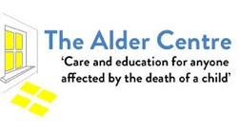
The Alder Centre

Provides services for anyone affected by the death of a child of any age and for any reason.
The Alder Centre works in a way that is based on including all and recognising individual difference. Some people prefer the comfort and guidance of other bereaved parents and others that of qualified and trained professionals. The Centre provides both types of support. The service works directly with bereaved parents and also extended family members and professionals who have been involved in the child’s life.
The Alder Centre also operates a national, free phone helpline staffed by trained bereaved parent volunteers
The helpline is open every day of the year - 0800 282 986 or 0808 800 6019

Alder Hey Children’s NHS Foundation Trust
Eaton Road
Liverpool
L12 2AP

0151 252 5391

Kinship Carers

Kinship Carers is a charity set up to support Kinship families who have taken on the responsibility of raising their grandchildren, nephews, nieces etc. when their biological parents can no longer raise them.
Kinship Carers offers support, advice, guidance and help put families in touch with other agencies. Through projects and workshops and one-to-one support with carers or children Kinship Carers promote equality, health and education to help improve self-esteem and confidence.

Ellergreen Community Centre
Liverpool
L11 2RY

0151 270 2108
kinshipcarerslp1@outlook.com

http://www.kinshipcarersliverpool.org.uk/

Winston’s Wish

Family Line 0845 2030405 national helpline offering guidance, information and support to anyone caring for a bereaved child, including professionals and family members.

http://www.winstonswish.org.uk/

Child Bereavement UK

Child Bereavement UK supports families and educates professionals when a baby or child dies or is dying, or when a child is facing bereavement. Every year they support over 6000 professionals, helping them to better understand and meet the needs of grieving families.

Support and information line - We provide confidential support, information and guidance to families and professionals. Our professionally trained bereavement support workers are available to take calls 9am-5pm Monday-Friday

0800 0288840

support@childbereavementuk.org

Hope Again

The youth website of Cruse Bereavement Care www.cruse.org.uk

It is a safe place, where young people who are facing grief can share their stories with others.
Here you will find information about our services, a listening ear from other young people and advice for anyone dealing with the loss of a loved one. Hope Again provides somewhere to turn to when someone dies.

Grief Encounter

Support bereaved children and their families to help alleviate the pain caused by the death of someone close. Support includes a helpline, family programme specialist resources and e-counseling.

www.griefencounter.org.uk

SeeSaw

Grief support for young children in Oxfordshire. SeeSaw offers a service that is very responsive to need and tailors support to meet the needs of individual families. SeeSaw is a member of the National Childhood Bereavement Network.

Many children and young people are offered face-to-face support from one of our support workers. SeeSaw pioneered the recruitment and training of volunteer support workers who visit children in their own homes.

http://www.seesaw.org.uk/

YoungMinds

YoungMinds is the UK’s leading charity committed to improving the emotional wellbeing and mental health of children and young people.
http://www.youngminds.org.uk/

Websites for bereaved teenagers

www.childbereavementuk.org/For/ForYoungPeople
Short films and film clips made by bereaved young people. Films include What Teachers Need To
Know, A Message to Parents, A Message To Friends, Messages From Young People Bereaved By Murder and Manslaughter.

www.rd4u.org.uk
Run by CRUSE Bereavement Care with a “Lads Only” section. Details of a confidential telephone number and private email service to contact a bereavement counsellor. Monitored message board to share experiences.

www.winstonswish.org.uk
Section for Young People has films and various options for support including frequently asked questions and a topic specific message board which is monitored.

www.griefencounter.org.uk
Support bereaved children and their families to help alleviate the pain caused by the death of someone close. Support includes a helpline, family programme specialist resources and e-counseling.

Resources for Teenagers

A Teenage Guide available from Child Bereavement UK costs 50p. A Pocket sized leaflet written by a bereaved teenager with advice and guidance.

Out of the Blue A workbook of tried and tested ideas for this age group to remember and express feelings. From Winstons Wish, cost £9.95.

Resources for Adults caring for bereaved teenagers

Young People, Death and the Unfairness of Everything by Nick Luxmore.

Explores the problems that arise when death is not openly discussed with young people and offers advice about how best to allay concerns without having to pretend that there are easy answers.

Children affected by the imprisonment of a family member
Children affected by the imprisonment of a family member are a highly vulnerable group. They face significant pressures during the period of imprisonment and are at risk of outcomes afterwards. Having a parent or other family member in prison can impact on a child’s sense of identity and how they interact with their family and community. It can also impact on their lives at school. It is crucial schools address the needs of children who are affected by this issue.
www.barnardos.org.uk

Supporting a child who has been bereaved through suicide
A death through suicide delivers a double blow to families-not only do they have to cope with a sudden and often unexpected death, but they also have to deal with the way their relative died. They may feel alone in their grief. In the UK on average someone takes their own life every 80 minutes. Many of these will be the parents or siblings of children who are left overwhelmed and bewildered by what has happened. With around 6,000 suicides a year in the UK, the impact is immense.
Book Beyond the Rough Rock from Winston’s Wish.
Red Chocolate Elephants; for children bereaved by suicide by Diana C. Sands
PAPYRUS Prevention of Young Suicide –PAPYRUS works to prevent young suicide and promote emotional wellbeing in young people. It listens to young people and their family and friends, especially suicide survivors www.papyrus-uk.org /01925 572 444

Support for refugee children
Schools and early years providers play a vital role in promoting the wellbeing of refugee children, helping them to rebuild their self –esteem and friendships, and achieve with their learning. For many refugee children, the experience of leaving their home and managing the transition into a new country with an unfamiliar language and culture will be challenging.
Refugee children and their parents have left countries that have conflict and human rights abuses. Some refugee children will have experienced bereavements and trauma or may be separated from parents and family members. Others may also be vulnerable to stressful circumstances in the UK such as financial hardship, changes to accommodation and school, tensions at home, racism and negative attitudes towards refugees.
However, most refugee children and young people are very resilient despite their experiences. Going to school provides daily structure and a sense of normality and stability: it also plays a key role in helping them adapt to the changes they have experienced.
Two really useful books to support are:
The Silence Seeker by Ben Morley and The Unforgotten Coat by Frank Cottrell Boyce
Please see reading list for further details.

Useful Websites
www.naldic.org.uk www.refugeecouncil.org.uk www.redcross.org.uk www.sec-ed.co.uk

Acknowledgements

This booklet would not be possible without the kind support and resources provided by:

Ann Farrell Outreach Manager SENIS
Special Educational Needs and Inclusion Service

Special thanks are given to Sonia Cross,

School Improvement Liverpool Ltd. who has produced this resource.

This booklet is the copyright of School

Improvement Liverpool.

Reading List

Using stories and activities can be a really good way to explore issues with a child who has been bereaved.

Winston’s Wish have created a suggested reading list, which they found helpful when working with bereaved children and young people. There are also textbooks and reference sources for people working in the area of child bereavement.

The books are arranged in the following categories:

- Books for children under 5.
- Books for age 5 to 8 years.
- Books for age 9 to 12 years.
- Books for age 13 to 16 years.
- Other helpful books (not directly about death).

The ISBN and publishing details have been taken from www.amazon.co.uk

Books available from Winston’s Wish are marked with asterisks ***each side of the title***.

Winston’s Wish,
3rd Floor,
Cheltenham House,
Clarence Street,
Cheltenham,
Gloucestershire,
GL50 3JR

Helpline: 08452 030405
Telephone: 01242 515157

Books for Children under the Age of 5

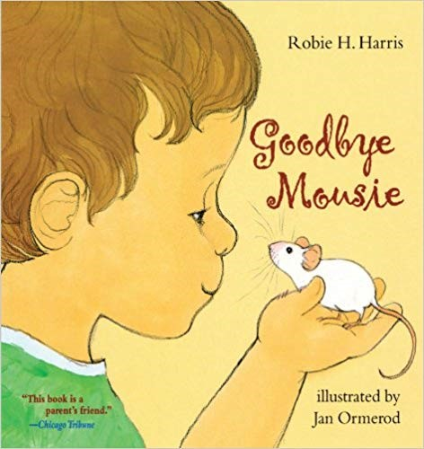 | Goodbye Mousie  Robie H. Harris & illustrated by Jan Ormerod  ISBN 978-0689871344  This beautifully illustrated picture book tells the story of a little boy who’s told that his pet mouse has died. At first, he doesn’t believe it, thinking it’s just asleep, but by asking lots of questions & with the help of his family he begins to accept Mousie’s death. This is a great story and would be very helpful to introduce death to young children and a starting point to discuss what happens after someone dies and the different feelings one may have.
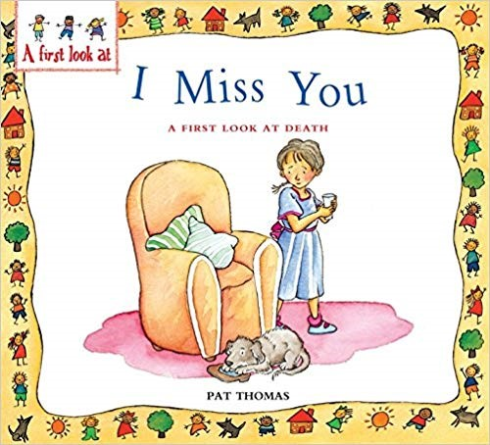 | I Miss You: A First Look at Death  Pat Thomas & illustrated by Lesley Harker,  ISBN: 978-0764117640  This bright and colourful picture book very simply talks about life and death. It briefly covers a range of issues such as why people die, how you may feel when someone dies and what happens afterwards. It includes questions for the reader to answer about their own experiences and a section at the back for adults on how to best use the book.  An excellent educational book, which could be used as a starting point for discussion.
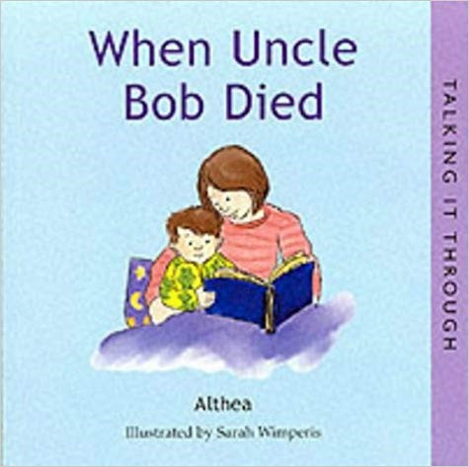 | When Uncle Bob Died (Talking it Through)  Written & illustrated by Lisa Kopper ISBN: 978-1903285084  A young boy talks about death and about Uncle Bob who died from an illness. It clearly explains some basic facts such as what ‘dead’ means and what a funeral is. It also talks about feelings and memories. This small picture book would be a good starting point for very young children with lots of opportunity for further discussion.
Dear Grandma Bunny
Written and Illustrated by Dick Bruna
ISBN: 978-1405219013

Suitable for very young children this book tells the story of what happened and how Miffy felt and coped when Grandma died.

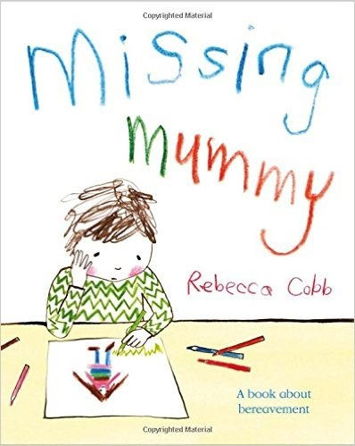 | Missing Mummy  Rebecca Cobb  ISBN: 978-0-230-74951-1  This extraordinary book deals with the loss of a parent from a child’s point of view. Perfectly pitched text and evocative artwork explore the many emotions a bereaved child may experience, from anger to guilt and from sadness to bewilderment. And importantly, the book also focuses on the positive – the recognition that the child is still part of a family, and that his memories of his mother are to be treasured.

Books for Children Age 5 to 8

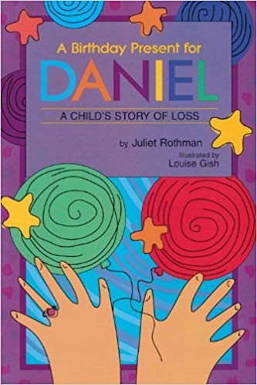 | A Birthday Present for Daniel: A Child's Story of Loss  By Juliet Cassuto Rothman  ISBN-13: 978-1573929462  Told by a young girl whose brother, Daniel, has died, she talks about how things have changed in the family. She also talks about the things she does when she is sad and how these differ from other members of her family. This book has small black and white pictures with minimal text, but it conveys some important issues. It would be particularly useful to broach the subject of birthdays as it describes how the family remembered Daniel on his birthday.
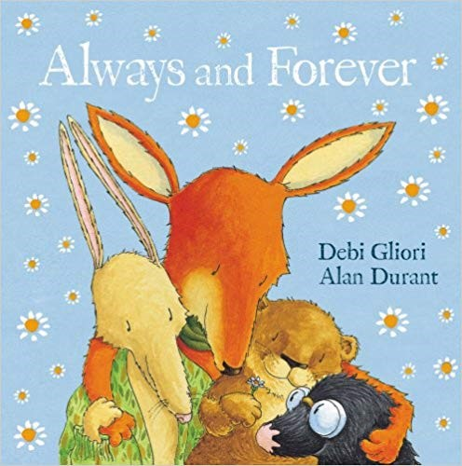 | Always and Forever  By Alan Durant & illustrated by Debi Gliori  ISBN: 978-0552548779  Otter, Mole and Hare miss Fox when he falls ill and dies. They stay at home and don’t want to talk about him because it makes them sadder. Then Squirrel visits and reminds them of all the fun times they had together. They all find a way to remember Fox and get on with their lives.  Colourful, detailed pictures in this book emphasise the importance of holding on to memories.
Badger’s Parting Gifts
Susan Varley
ISBN: 978-0006643173

Badger is old and knows he is going to die soon. When he does, the other animals think they will be sad forever, but they begin to talk about the memories they have of the things Badger taught them and learn to cope with his death. A lovely picture book that emphasises the importance of remembering the person who has died.
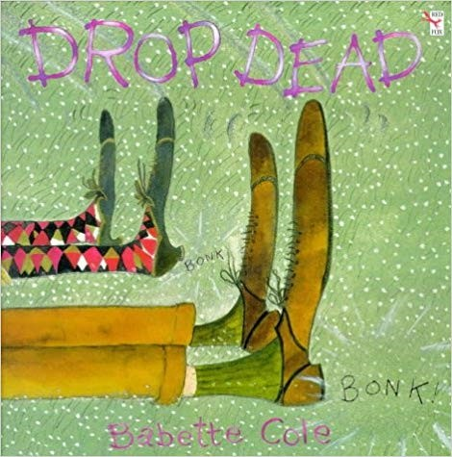 | Drop Dead  Babette Cole  ISBN: 978-0099659112  A humorous book with comic-like pictures, two ‘bald old wrinklies’ tell their grandchildren about their life growing up and how one day they will just drop down dead. It is a light-hearted book about life that emphasises the normality and inevitability of dying. It is very direct, and some readers may not like its style.
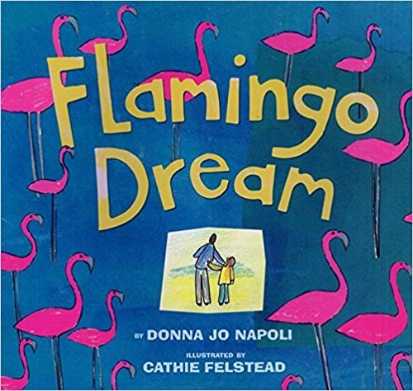 | Flamingo Dream  Donna Jo Napoli & illustrated by Cathie Felstead  ISBN: 978-0688167967  In this bright and colourful book, a young boy tells the story of his Dad who is seriously ill and dies soon after a trip to Florida to see the place where he grew up. The collage style illustrations capture the things the boy collects to remind him of his Dad.

Fred
Posy Simmonds
ISBN: 978-0099264125 1998

A light-hearted book with detailed illustrations about Fred, Nick and Sophie’s lazy cat that dies. After burying him in the garden, they wake up at night to find all the cats in the area have come to say goodbye to Fred, the famous singer! This funny and touching story would be useful to introduce death to children.
Granpa - The Book of the Film
Based on the story by John Burningham
ISBN: 978-0721414768

This beautifully detailed picture book has very few words but tells the story of a little girl’s relationship with her Granpa. It takes the reader through many happy times they spent together playing games, telling stories and on outings. On the last page, Granpa’s chair is empty, signifying that he has died. Children may benefit from reading this book with an adult to talk about the pictures and to elaborate some of the messages it conveys.
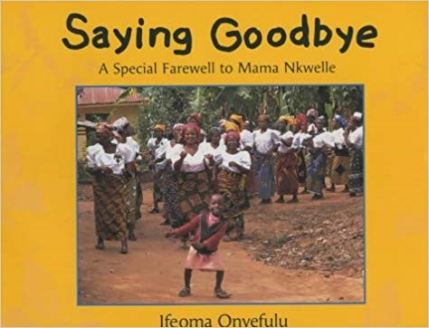 | Saying Goodbye: A Special Farewell to Mama  Nkwelle By Ifeoma Onyefulu  ISBN: 978-0711217010  This book has large bright colourful photos and follows a little boy, Ikenna describing what happens at the ceremony after his great-grandmother’s funeral. It gives ideas of different ways to remember someone and an insight into Nigerian culture. A lovely book that could be used in many different situations, including schools.
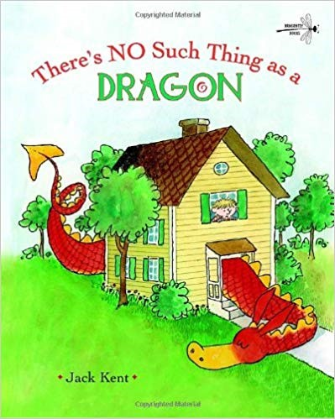 | There’s NO Such Thing as a Dragon  By Jack Kent Happy Cat Books  ISBN: 978-1899248957  This relates the charming tale of Billy Bixbee, who awakens to find a dragon "about the size of a kitten" sitting on his bed. The dragon grows by leaps and bounds, until Billy dares to pet the attention-seeking creature and it shrinks back down into an adoring little lap dragon.
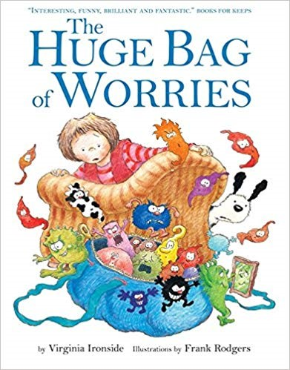 | The Huge Bag of Worries  Virginia Ironside & illustrated by Frank Rodgers, ISBN: 978-0340903179  Jenny begins to worry about lots of different things and these worries build up and get out of control. She just can’t get rid of them, until she meets the old lady next door who helps her feel better. A lovely story with fun illustrations encourages children to talk about their worries.
The Sunshine Cat
Miriam Moss, Illustrated by Lisa Flather ISBN: 978-1841215679

Sunny the cat is loved by all his human family, but one day there is a knock at the door – Sunny has been killed in an accident. A sensitive story which aims to help children come to terms with death.

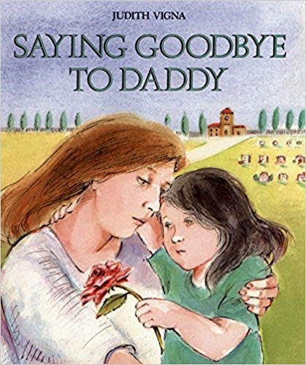 | Saying Goodbye to Daddy  Judith Vigna  ISBN: 978-0807572535  Clare’s Dad died in a car accident and this book looks at changes in the family, difficult feelings, funerals and memories through the eyes of Clare. It would also be a good book to help parents understand the child’s perspective. It gives good examples of how adults can answer children’s questions, emphasising the need to be clear and honest.
The Tenth Good Thing About Barney
Judith Viorst & illustrated by Erik Blegvad ISBN: 978-0689712036

A young boy’s cat dies and his parents suggest that he could think of ten good things about Barney to tell at the funeral. But he can only think of nine, until he talks to his Father about what happens to someone after they have died, and he discovers the tenth. A carefully written book with black and white pictures, that sensitively deals with death and lets the reader make his or her own decisions about what happens after the funeral.
All Kinds of Feelings: A Lift The Flap Book
Emma Brownjohn,
ISBN: 978-0230749511

All Kinds of Feelings "How do you feel? Do you ever feel angry, or sad, or excited, or jealous?" This lift-the-book prompts young children to learn about the different feelings everyone has, and says it's ok to accept and trust your feelings and to express them--but also that it's good to think why we feel a certain way and whether it's fair.
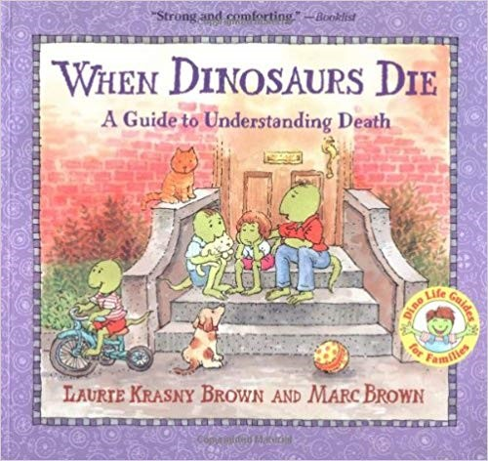 | When Dinosaurs Die: A Guide to Understanding Death  Laurie Krasny & illustrated by Marc Brown ISBN: 978-0316119559,  This factual picture book uses cartoon dinosaurs to illustrate the text and comment on what is said. It is a bright and colourful book that explains death in a simple and unthreatening way. It covers many issues including ‘why does someone die?’, ‘feelings about death’ and ‘saying goodbye’. It would be an excellent resource for anyone caring for young children.
The Heart and The Bottle
Oliver Jeffers
ISBN: 978-0007429004

Award-winning picture book star Oliver Jeffers explores themes of love and loss in this lifeaffirming and uplifting tale. Once there was a girl who was full of wonderment at how the world worked. She shared all her dreams and excitement with her father, who always had the answer to every question. That is until one day when his chair was empty, not to be filled again – how would she find the meaning of life now?
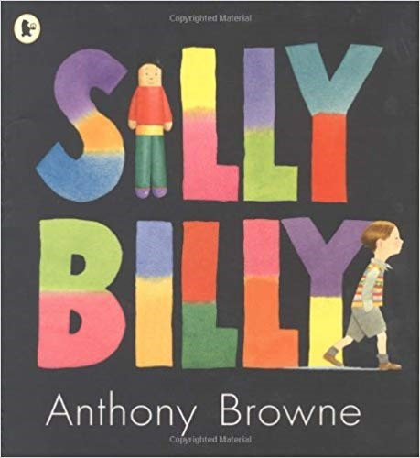 | Silly Billy  Anthony Browne  ISBN: 978-1406305760  Billy is a bit of a worrier. He worries about hats and shoes. He worries about clouds and rain and giant birds. Most of all, he worries about staying at other people's houses. His mum and dad try to help, but still Billy worries...until a visit to his grandma's shows him how to overcome his fears with the aid of his imagination -and some tiny worry dolls.
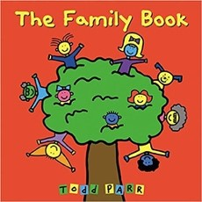 | The Family Book  Todd Parr  ISBN: 978-0316070409  The Family Book celebrates the love we feel for our families and all the different varieties they come in. Whether you have two mothers or two dads, a big family or a small family, a clean family or a messy one, Todd Parr assures readers that no matter what kind of family you have, every family is special in its own unique way.
67
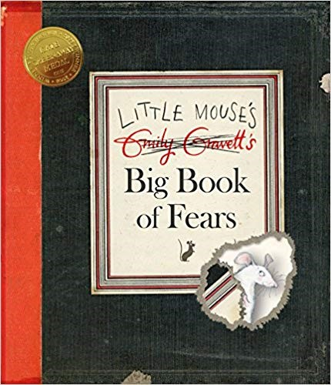 | Little Mouse’s Big Book of Fears  Emily Gravett  ISBN: 978-0230016194  Young children will identify with the little mouse who uses the pages of this book to document his fears – from loud noises and the dark, to being sucked down the plughole. Packed with details and novelty elements including flaps, die-cuts and even a hilarious fold-out map, this is an extraordinary picture book.
Rabbityness
Jo Empson
ISBN: 978-1846434822

Rabbit enjoys doing rabbity things, but he also loves un-rabbity things! When Rabbit suddenly disappears, no one knows where he has gone. His friends are desolate. But, as it turns out, Rabbit has left behind some very special gifts for them, to help them discover their own unrabbity talents!

The Lonely Tree
Nicholas Halliday
ISBN: 978-0953945986

The Lonely Tree is a charmingly illustrated picture book which will help children and their families in times of loss or change with the gentle reassurance that saying goodbye is a natural part of life.

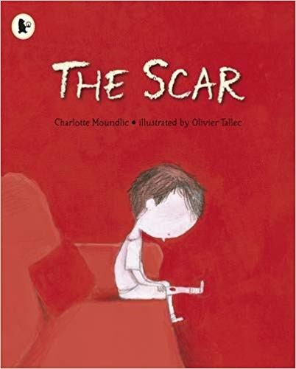 | The Scar  Charlotte Moundlic  ISBN: 978-1406335958  When the boy in this story wakes up to find that his mother has died, he is overwhelmed with sadness, anger and fear that he will forget her. He shuts all the windows to keep in his mother's familiar smell and scratches open the cut on his knee to help him recall her comforting voice. He doesn't know how to speak to his dad any more, and when Grandma visits and throws open the windows, it's more than the boy can take -until she shows him another way to hold on to the feeling of his mum's love.
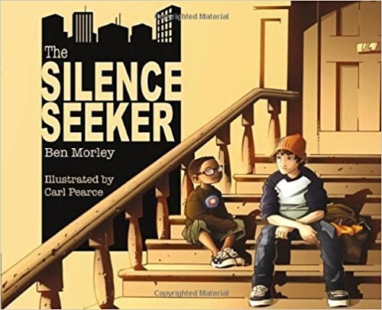 | The Silence Seeker  Ben Morley  ISBN-10:184853003X  When a new family moves in next door, Joe's mum explains that they are asylum seekers. Joe hears that they are silence seekers, especially as Mum adds that they need peace and quiet. When he sees a young boy from the family sitting disconsolately on the steps, Joe decides to help him find a quiet place in the noisy and chaotic city. A simple, moving story which is the perfect way to gently open discussion around the refugee crisis.

Books for Children Age 9 to 12

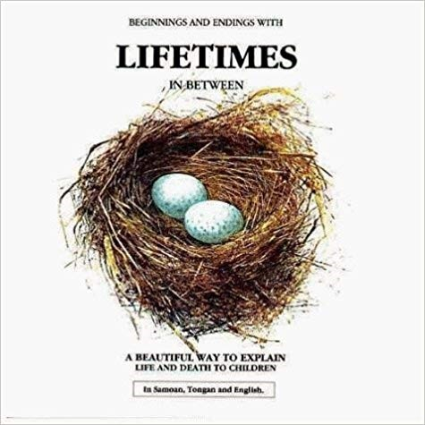 | Beginnings and Endings with Lifetimes in Between  Bryan Mellonie & Robert Ingpen,  ISBN: 978-1855617605  This thought provoking book has large pictures complemented with small sections of text. It clearly explains about life and death focussing on plants, animals and insects before moving on to people. It emphasises that death is part of the life cycle and is natural and normal whenever it occurs. A simple book with a powerful message.
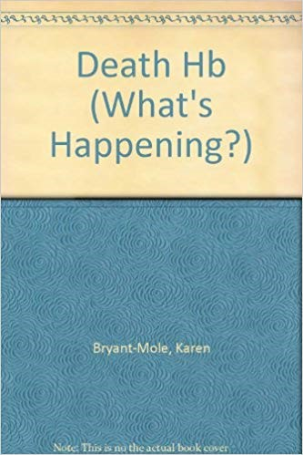 | Death: What’s Happening?  Karen Bryant–Mole  ISBN: 978-07502137901994  This factual book has clear text and large photos. It uses stories of young people to discuss issues surrounding death such as feeling frightened, the funeral and the future. It includes advice on how to feel better and cope with difficult situations after someone has died. Using straightforward language, this book may reassure the reader there are other young people who have had someone important to them die and answer some of their questions and concerns.
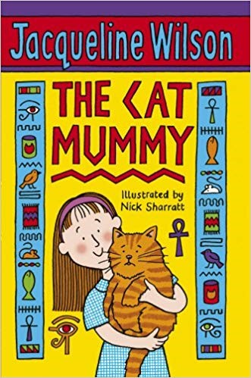 | The Cat Mummy  Jacqueline Wilson & illustrated by Nick Sharratt  ISBN: 978-0440864165  Verity’s Mum died the day she was born but she rarely talks about her. Verity doesn’t want to upset her Dad or Grandparents.  This humorous but sensitive story mainly focuses on Verity’s missing cat Mabel but reveals some of the misunderstandings and anxieties children can have about death. It also shows it can be good to be open, honest and to talk about difficult issues.
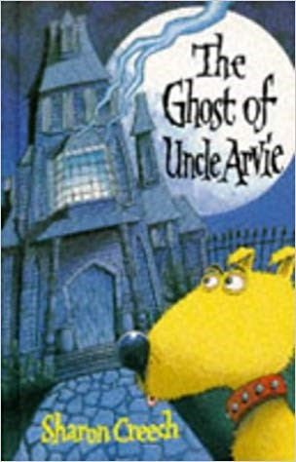 | The Ghost of Uncle Arvie  Sharon Creech  ISBN: 978-0333656327  This fun and humorous book is about Danny, an ordinary nine-year-old boy. However, once or twice a year a ghost visits him. This time it is the ghost of his Uncle Arvie who follows him, persuading him to make his three wishes come true. As a result, Danny and his dog get into adventures which make him think about his dad who has also died.  This book has some important messages and talks about death in an open way, but is primarily fun and imaginative.
The Mountains of Tibet
Mordicai Gerstein
ISBN: 978-1782850472

Based on Tibetan teachings, this book tells of a small boy who grows up to be a woodcutter. When he dies, he discovers there is a chance to live again but first he must make a number of choices. A simple tale with deep meaning but the theme of reincarnation could be confusing.

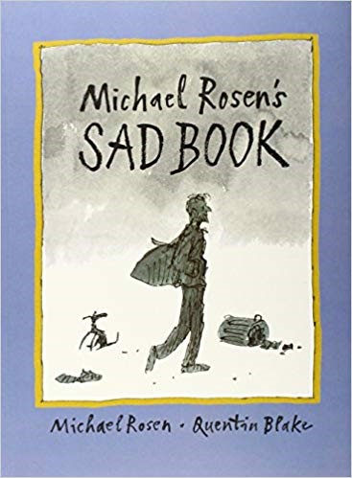 | Michael Rosen’s SAD BOOK  Michael Rosen & illustrated by Quentin Blake ISBN: 978-1406313161  This book has large illustrations and small snippets of text. It is wonderfully honest and will appeal to children and adults of all ages. We all have sad stuff, but what makes Michael Rosen most sad is thinking about his son who died. This book is a simple but emotive story. He talks about what sad is and how it affects him and what he does to cope with it. In true Michael Rosen style, this book manages to make you smile as well.
Losing Uncle Tim
Mary Kate Jordan & illustrated by Judith Friedman ISBN: 978-0807547564

This picture book for slightly older children explains how a young boy finds out his Uncle Tim has AIDS and is going to die. It is a serious and sensitive book covering many of the issues, changes and difficult feelings that can occur when someone has a serious illness.

***Milly’s Bug Nut***
Jill Janney
ISBN: 978-0-9539123-4-6

A short, simple story with black and white pictures, of a young girl who’s Dad has died. It talks about the ups and downs of family life and how things slowly get easier as time goes. Milly misses her Dad and things are just not the same anymore. She knows when people die, they can’t come back but she still keeps a wish to see her Dad one more time.

The Best Day of the Week
Hannah Cole & illustrated by John Prater ISBN: 978-0744554670

This storybook tells of two young children who spend Saturdays with their Grandparents when Mum is at work. It has three chapters, with stories of three different Saturdays. The first is a happy day; the second is at the hospital and sad as Granny dies, the third at the theatre. It is a lovely story that gives an important message that it is still okay to have fun after someone dies.

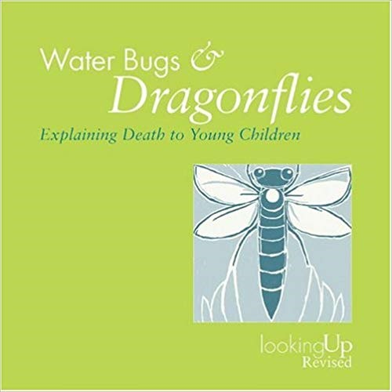 | Water Bugs and Dragonflies  Doris Stickney & illustrated by Gloria Stickney ISBN: 978-0264674414  This pocket size booklet with small black and white pictures is based on a fable, associating death with a water bug’s transformation into a dragonfly. It portrays the mystery around death but may need an adult to explain the analogy and help a child relate it to their own experience. It uses Christian beliefs with a focus on life after death and also contains advice for parents.
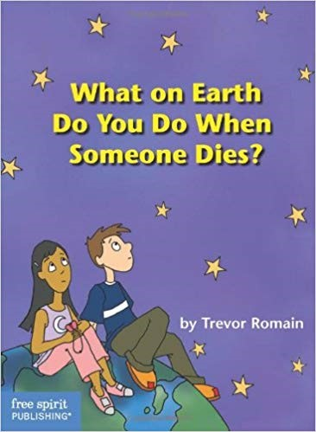 | What on Earth Do You Do When Someone Dies?  Trevor Romain  ISBN: 978¬1575420554  This book for older children is a factual guide, answering questions such as ‘why do people have to die?’, ‘is it okay to cry?’ and ‘what is a funeral/memorial service?’ It is written in a straightforward way, with practical tips, advice and information about different faiths and beliefs.
Ways to Live Forever
Sally Nicholls
ISBN: 978-1407104997

If I grow up," 11-year-old Sam informs readers, "I'm going to be a scientist." He says "if" because he has acute lymphoblastic leukaemia and knows he probably won't. With the encouragement of his tutor, he starts to write a bit about himself, then more, until he is using his writing to sort out his death. Interspersed with Sam's lists, questions and odd bits of mortality facts on notebook paper, his narrative proceeds in short, candid chapters that reveal a boy who, though he's not ready to die, nevertheless can confront the reality with heart-breaking clarity. As his parents wrangle about treatment (he doesn't want it), his little sister grapples with the changes to the household and his best friend and fellow cancer-sufferer dies, Sam methodically works through the things he wants to do before he dies, from going up a down escalator to the more problematic ride in an airship and seeing the earth from space.

Red Chocolate Elephants; for children bereaved by suicide
Diana C.Sands
ISBN: 978-0646542379

This important publication (including a DVD) provides a sensitive and appropriate means of engaging with children around the difficult question of death through suicide. Red Chocolate Elephants will be a valuable tool for those supporting children in schools and other settings, and provides an important bridge into exploring this complex and confusing experience.

Beyond the Rough Rock: Supporting a Child Who Has Been Bereaved Through Suicide
Di Stubbs / Publisher: Winston's Wish
ISBN: 9780953912377

Explaining to a child that someone has died by suicide is possibly one of the most difficult situations that a parent or carer might ever face. This booklet offers practical advice for families in the immediate days and weeks when suicide has been the cause of death.

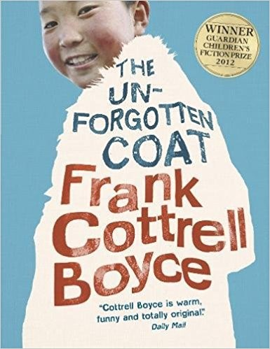 | The Unforgotten Coat  Frank Cottrell Boyce  ISBN-10: 1406341541  Two refugee brothers from Mongolia are determined to fit in with their Liverpool  schoolmates, but bring so much of Mongolia to Bootle that their new friend and guide, Julie, is hard-pressed to know truth from fantasy. Told with the humour, warmth and brilliance of detail which characterizes Frank Cottrell Boyce's writing, readers will be transported from the streets of Liverpool to the steppe of Mongolia.

Books for Young People age 13 to 16

The Death and Life of Charlie St. Cloud
Ben Sherwood
ISBN: 978-0330488907

The eponymous hero of The Death and Life of Charlie St Cloud is a good boy; an American teenager who works hard at school, is good at sport and loves his mum and his little brother Sam. And then one terrible day, tragically, he finds himself responsible for Sam's death. Charlie dies too for a brief moment but is brought back to life by the skill of a paramedic. From that moment on, Charlie makes a sacrificial decision to live his life in the past. Until that is, he meets tough but beautiful yachtswoman Tess and he has to rethink life and death.

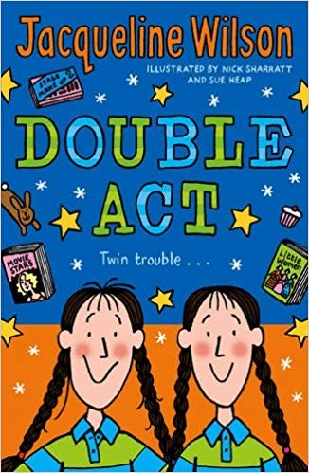 | Double Act  Jacqueline Wilson & illustrated by Nick Sharratt, ISBN: 978-0440867593 (Also on audiocassette)  Ruby and Garnet are 10-year-old twins. They do everything together, especially since their mum died three years ago. When their dad finds a new partner and they move house, Ruby and Garnet find it hard and get into all sorts of trouble. Eventually, they settle down and learn to live with the changes. A lively and humorous book that deals sensitively with change.
Dustbin Baby
Jacqueline Wilson
ISBN: 978-0552547963 (Also on audiocassette)

April was abandoned in a dustbin as a baby on the 1st April. Having spent all her life in a children’s home and with different foster parents (one of whom committed suicide), things haven’t been easy and April is struggling. Now she’s fourteen and on her birthday, determined to find out more about her past, sets off to find some important people. This is an emotive book with a great storyline in usual Jacqueline Wilson style It is open and honest.
Straight Talk about Death for Teenagers: How to Cope with Losing Someone You Love Earl A. Grollman,
ISBN: 978-0807025017

This book was written after the author spoke to thousands of teenagers and found they often felt forgotten after someone has died. Written in short, clear sentences that are easy to read, it covers feelings, different types of death and the future. This book gives the reader many options of what can happen, how s/he may feel, giving advice and reassuring readers grief is normal.
The Charlie Barber Treatment
Carole Lloyd
ISBN: 978-0744554571

Simon’s Mum died suddenly from a brain haemorrhage and he came home from school to find she had died. With his GCSE coursework piling up and having to help around the house, Simon finds it hard and doesn’t go out much with his friends. He then meets Charlie, who is visiting her Grandma, and believes their meeting was fate. Simon starts to enjoy life again and to re-build relationships with his family and friends. A sensitive and realistic book that conveys some of the thoughts and emotions of a teenage boy.

The Lost Boys’ Appreciation Society
Alan Gibbons
ISBN: 978-1842550953

Teenage life is difficult enough for Gary and John, but when their Mum dies in a car accident, things get steadily worse. John struggles to keep the peace as Gary goes off the rails, saying his new mates are now his family. With GCSE exams looming and his Dad going out on dates, things become unbearable for John. A gripping book exploring relationships and how different people react to life events.
Vicky Angel
Jacqueline Wilson & illustrated by Nick Sharratt, ISBN: 978-0440865896

When Jade’s best friend Vicky, is run over by a car and dies in hospital everyone at home and school starts treating her differently. ‘Vicky Angel’ then starts following Jade around, distracting her and getting her into trouble. This moving but amusing story illustrates how hard it is to carry on with everyday life after a tragic accident

The Spying Game
Pat Moon
ISBN: 978-1842750049

Joe’s dad died in a car accident and he feels really angry towards the man who killed his father. He decides to set up a secret ‘Nightmare Plan’ to vent his anger and begins to persecute the man and his family by scratching his car and sending hate mail. This powerful book reveals the difficult emotions Joe faces both at home and at school. A very readable and fast paced book that would appeal to many young people.
The Man who didn’t want to die: From The Barefoot Book of Buddhist Tale
Retold by Sherab Chodzin & Alexandra Kohn Illustrated by Marie Cameron ISBN: 1841480096

This short story is based on a Japanese folk tale and approaches death from an unusual angle. When a man decides he doesn’t want to die, he is sent to the Land of Never-ending Life and expects to meet the happiest people in the world. However, the realities of living forever are not as attractive as he thought he consequently learns an important lesson. This story is very thought provoking.

Before I Die
Jenny Downham David Fickling
ISBN: 978-0385613460

With only months left to live, 16-year-old Tessa makes a list of things she must experience: sex, petty crime, fame, drugs and true love. Downham's wrenching work features a girl desperate for a few thrilling moments before leukaemia takes her away.
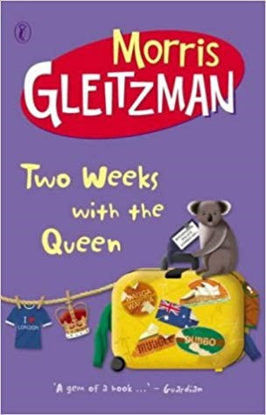 | Two weeks with the Queen  Morris Gleitzman  ISBN-13: 978-0141303000  Colin Mudford is on a quest. His brother Luke has cancer and the doctors in Australia don't seem to be able to cure him. Sent to London to stay with relatives, Colin is desperate to do something to help Luke. He wants to find the best the doctor in the world. Where better to start than by going to the top? Colin is determined to ask the Queen for her advice.
Up on Cloud Nine
Anne Fine
ISBN: 978-0552554657

Stol falls out of a top floor window and ends up unconscious in hospital with lots of broken bones and no-one knows whether it was attempted suicide or an accident. This book is written from the perspective of his best friend Ian whilst he is sitting by his bedside. He recalls all the fun times they have had together as well as acknowledging the slightly different way Stol sees the world. Ian captures the emotions of his own adoptive parents as well as Stol’s family and the hospital staff in an amusing yet moving way illustrating how Stol has had an inspirational effect on everyone. (Also available in audiocassette).

Ostrich Boys
Keith Gray
ISBN: 978-0099456575

It's not really kidnapping, is it? He'd have to be alive for it to be proper kidnapping.' Kenny, Sim and Blake are about to embark on a remarkable journey of friendship. Stealing the urn containing the ashes of their best friend Ross, they set out from Cleethorpes on the east coast to travel the 261 miles to the tiny hamlet of Ross in Dumfries and Galloway. After a depressing and dispiriting funeral, they feel taking Ross to Ross will be a fitting memorial for a 15 year-old boy who changed all their lives through his friendship. Little do they realise just how much Ross can still affect life for them even though he's now dead. an extraordinary novel about friendship, loss and suicide, and about the good things that may be waiting just out of sight around the corner...

Other helpful books (not directly about death)

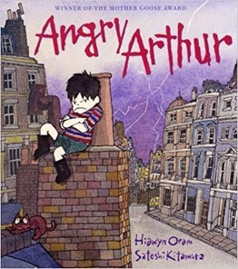 | Angry Arthur  Hiawyn Oram & illustrated by Satoshi Kitamura ISBN: 978-0099196617  It’s time for bed but Arthur wants to stay up so he gets really angry. Every time someone tells him ‘that’s enough’ his anger gets bigger and bigger and takes over the world until he wonders why he was so angry in the first place. A wonderful imaginative story that many children (and adults) will be able to relate to.
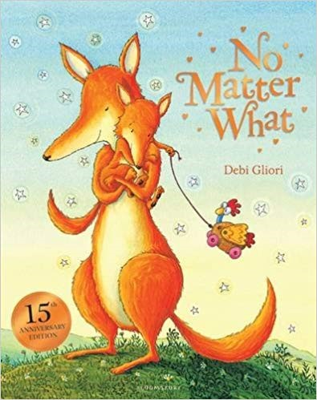 | No Matter What  Debi Gliori  ISBN: 978-0747563310  A rhyming story with large, bright pictures about Small, a young fox who is feeling cross because no one loves him. Large, then reassures him that she’ll love him no matter what. A fun and imaginative book that only briefly talks about death but would be a useful to help support a young child through difficult times.
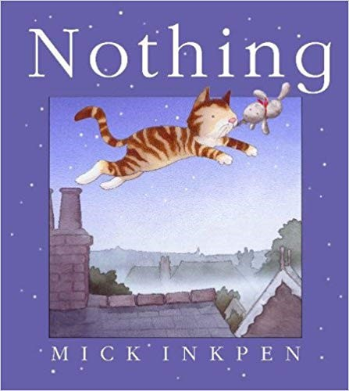 | Nothing  Mick Inkpen  ISBN: 978-0340918166  A ‘little thing’ has been stuck in the attic for so long, he has even forgotten its name. When the owners move house and leave him behind, he sets off on an adventure to discover who he really is. A lovely book about families and the feeling that you belong. It could be used in many situations, particularly with a child who is feeling unsettled.
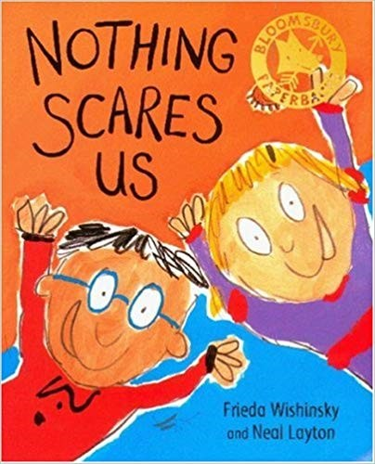 | Nothing Scares Us  Frieda Wishinsky & illustrated by Neal Layton ISBN: 978-0747550433  Lucy and Lenny are the ‘fearless two’, best friends who have all sorts of adventures. Lenny then starts watching a scary programme on TV, which gives Lucy nightmares and she dare not tell Lenny in case he laughs at her. With bright colourful pictures, this fun book is a comforting story about friendship and adventure.
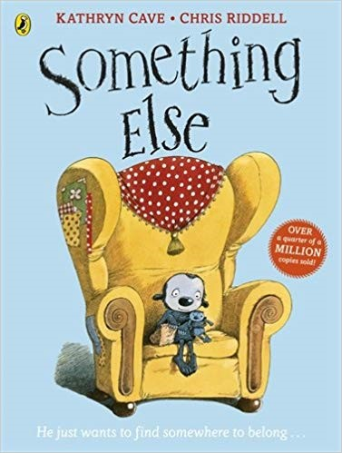 | Something Else  Kathryn Cave & illustrated by Chris Riddell ISBN: 978-0140549072  Something Else doesn’t belong and has no one to be friends with, until one day Nothing knocks at his door and although they seem very different, they get along and become friends. These unusual looking characters capture the feelings of young people in a sensitive and fun way. A lovely book that could reassure children who feel unsettled within their peer group.

There are also many books where death is not the main focus of the story but features bereavement or the main character has been bereaved.

These include:
- A Little Princess
- Charlotte’s Web
- Danny the Champion of the World
- Bambi
- Harry Potter and the Philosopher’s Stone
- James and the Giant Peach
- Little Women
- Oliver Twist
- The Secret Garden

Books for Adults Supporting a Bereaved Child

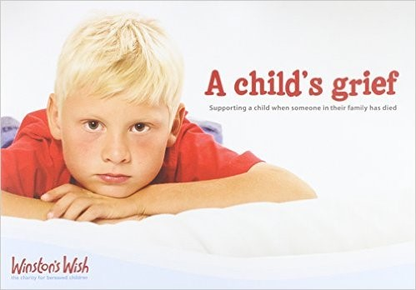 | ***A Child’s Grief: Supporting a child when someone in their family has died***  Julie Stokes, Diana Crossley, Katrina Alilovic & Di Stubbs.  ISBN: 978-0-9559539-0-3  A useful and informative introduction for any adult who is supporting a child through bereavement. Covering a variety of issues that may affect a child when a person close to them dies, both immediately and in the longer term, the booklet also offers practical activities to do together and a section on further reading and support.
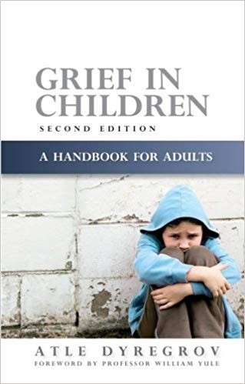 | Grief in Children: A Handbook for Adults  Atle Dyregov  ISBN: 978-1843106500  This is a very practical and useful book written for adults to help them understand how children feel when someone important in their life dies. It covers areas such as children’s grief reactions at different developmental levels, sex differences and different types of death. It makes many useful suggestions about how children can be helped to cope with their grief in an open, honest and positive way.
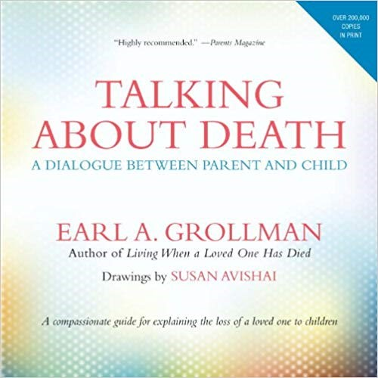 | Talking about Death: A Dialogue Between Parent and Child  Earl A. Grollman  ISBN: 978-0807023631  This guide for parents recognises that many adults find it hard to honestly and openly explain death to children, especially when faced with their own grief. It includes quotes and examples from other parents and suggestions of what to say to a child as well as general advice.
SAD BOOK
Michael Rosen, Illustrated by Quentin Blake. ISBN: 978-1406313161

We all have sad stuff - maybe you have some right now, as you read this. What makes Michael Rosen most sad is thinking about his son, Eddie, who died. In this book he writes about his sadness, how it affects him and some of the things he does to try to cope with it. Whether or not you have known what it's like to feel really deeply sad, its truth will surely touch you.

And When Did You Last See Your Father
Blake Morrison
ISBN: 978-1862079083

The book tells of how Dr Morrison’s life slowly slips away during the last few weeks of his life. Interspersed with this are the authors recollections of his father, who whilst being a difficult man at times, always remained a loving husband and father. The author is at all times open and honest - sometimes brutally so - and lays open his feelings for all to share.

