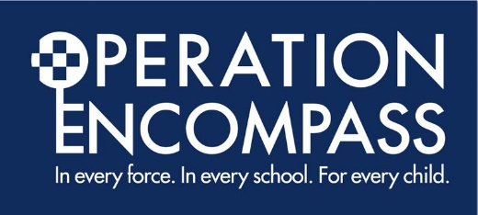
Letter to Parents - Dojo

Operation Encompass Parents Awareness Letter October 2022
Dear Parent/Carer,
This letter is to remind you that our school is participating in Operation Encompass.
Operation Encompass is a unique Police and Education early intervention safeguarding partnership which ensures that a child/ young person's school/ college is informed, prior to the start of the next school day, that there has been a domestic abuse, vulnerable child or missing incident to which the child or young person has been exposed, and which might then have an impact on them in school/ college the following day.
Each school is informed of all such incidents, not just those where an offence can be identified or those which are graded as high risk. The partnership recognises that all domestic abuse, vulnerable child and missing incidents can be harmful to children and young people.
This information will be shared throughout the year, including holidays and weekends. Information will only be shared with the school by the police where it is identified that a young person was present, witnessed or was involved.
A nominated member of staff, known as a Key Adult, has been trained to liaise with the police. At St Charles’ Catholic Primary School our Key Adult is Mrs Dean. They will be able to use information that has been shared with them, in confidence, to ensure that the school makes provision for possible difficulties experienced by children or their families. The Key Adults will keep this information confidential and will only share it on a need-to-know basis, for instance, to teaching staff for the child or young person. It will not be shared with other school students.
This national initiative has been implemented across the whole of the Merseyside Police area. If you would like some more information about it, you can view it online at www.operationencompass.org
We are keen to offer the best support possible for our pupils and a recent review of Operation Encompass showed that it is beneficial and supportive for all those involved.

Website

OPERATION ENCOMPASS
As part of St Charles’ Catholic Primary School’s commitment to keeping children safe, we are proud to be part of the national initiative ‘Operation Encompass.’
The purpose of Operation Encompass is to safeguard and support children and young people who have been involved in or witness to a domestic abuse, vulnerable child or missing incident.
Operation Encompass has been created to address such situations that create a safeguarding risk to young people. It is the implementation of key partnership working between the police and schools/ colleges. The aim of sharing information with local schools/ colleges is to allow ‘Key Adults’ the opportunity of engaging with the child and to provide access to support that allows them to remain in a safe but secure familiar environment.
Following the report of a domestic abuse, vulnerable child or missing incident, by 9.00am on the next school day the school’s Key Adult will be informed of the child or young person’s involvement. This knowledge, given to educational establishments through Operation Encompass, allows the provision of immediate early intervention through silent or overt support dependent upon the needs and wishes of the child.
The purpose and procedures in Operation Encompass have been shared with all parents and governors, is detailed as part of the school’s Safeguarding Policy and published on our school website.
This is a valuable initiative that means we can help and support our children and their families within our school when they need us most.
If you have any questions or wish to know more about our involvement in Operation Encompass, please do not hesitate to contact Mrs Dean at school.
You can also find out more information by visiting the Operation Encompass website by clicking on the link below.
https://www.operationencompass.org/

