The Autumn term’s theme in Religious Education is about understanding where we come from in the light of Creation, explored through the topics ***Family, Belonging and Loving.*** We willalso spend two weeks finding out about other World religions – Judaism and Islam.

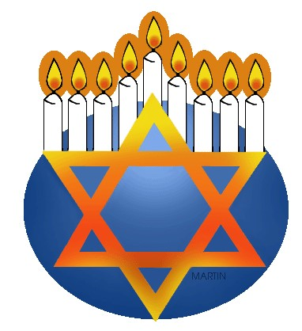

**DOMESTIC CHURCH - FAMILY**

(4th September - 29th September)

In the first topic, the children will focus on life as a gift, ourselves as unique and loved creations, and the love and care that can be expressed in our family groups.

***Suggestions for home activities***

***Make a collage using family photos of all significant family members – grandparents, parents, children, aunts, uncles, cousins etc - including those who may have died.***

**OTHER WORLD RELIGION - Judaism**

(2nd October – 6h October)

Each year group will be learning about a different aspect of Judaism, its beliefs and practices.

***Suggestions for home activities***

***Ask children to tell you about what they have learnt, and maybe research some other facts about the Jewish people and their faith.***

**OTHER WORLD RELIGION – Sikhism**

(13th October – 17th October)

Each year group will be learning about a different aspect of the beliefs and practices of the followers of Sikhism.



***Suggestions for home activities***

***Ask children to tell you about what they have learnt, and maybe research some other facts about Sikhism.***

**BAPTISM/CONFIRMATION - BELONGING**

*(9th October – 10h November)*

In the next topic, we will focus on the call to belong, and on Baptism and Confirmation, sacraments of God’s gift of life and friendship.

***Suggestions for home activities***

***Talk about your child’s baptism, how special it was, and the people who shared the day with you. Look at photos if possible.***

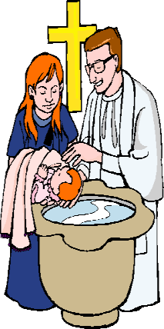

**ADVENT/CHRISTMAS - LOVING**

*(20th November –15th December)*

The final topic of the term is ***Loving.*** The children will focus on our capacity to enter into loving relationships and the perfect gift, given in God’s love, Jesus, who was born as one of us.

***Suggestions for home activities***

***Discuss how your family welcomes visitors to your home.*** Find out about some Christian symbols for Advent - Advent wreath, calendar, Jesse tree. ***Use the CAFOD website to get a religious Advent calendar.***



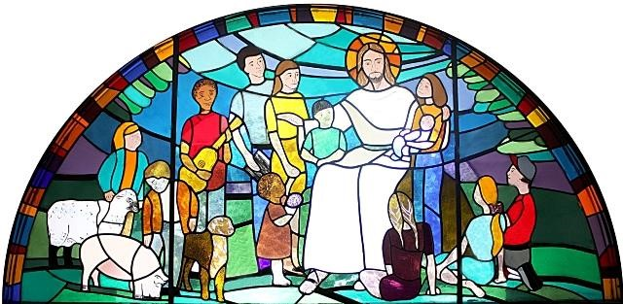

***‘Come and See’***

Religious Education

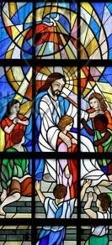

Parents’ Newsletter

Autumn Term 2023

*‘Come and See at Home’*

**Special Feast Days and Celebrations**

**All Saints**

(1st November)

We celebrate the lives of special and ordinary people who have responded to God’s invitation to love.

**The commemoration of all the faithful departed**

**(All Souls** 2nd November)

Today and throughout the rest of November we pray for those who have died.

Eternal rest grant unto them, O Lord, and let perpetual light shine upon them.

May they rest in peace. Amen.

**FEAST OF ST CHARLES**

(4th November)

**Our lord jesus Christ, King of the universe**

(21nd November)

**ADVENT**

(Begins 3rd December)

Advent means ‘coming’. We think of the coming of Jesus when he was born but we also think of his promise that he would come again at the end of time. It is a time of waiting and preparing. It is only in the last week of Advent that we focus upon the events to be celebrated at Christmas.

**The Immaculate Conception of the blessed virgin mary**

(8th December)

This feast marks the first stage of the existence of Mary, the mother of Jesus.

She was ‘full of grace’ from the very beginning and

co-operated with God throughout her life.

**Christmas Day, The nativity of the lord**

(25th December)

On this day we begin our celebration of the birth of Christ.

**The holy Family of jesus, mary and joseph**

(26th December)